Anthony Ronald Gaudin
October 24, 1948 – September 13, 2011

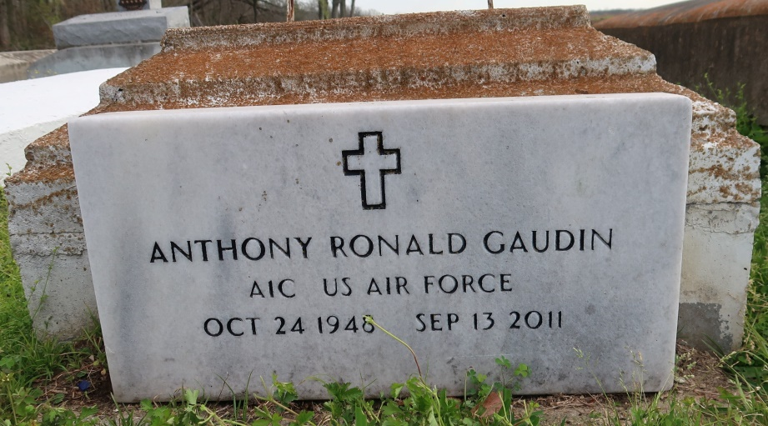

Anthony Ronald Gaudin
A native and resident of Convent, he died at 5:50 a.m. Tuesday, Sept. 13, 2011, at The Carpenter House of St. Joseph Hospice in Baton Rouge. He was 62.
Visiting at St. Michael's Catholic Church, Convent, on Tuesday, Sept. 20, from 9:30 a.m. until Mass of Christian Burial at 11 a.m. Burial in St. Mary's Cemetery, Convent.
Survived by his mother, Mary Louise Washington Gaudin; sister and husband, Agnes and Samari Brown; brother and wife, Roland and Lorraine Gaudin; and two nieces, numerous cousins, other relatives and friends.
Preceded in death by his father, Ronald Gaudin.
Arrangements by Brazier-Watson Funeral Home, Donaldsonville.
Advocate, The (Baton Rouge, LA)
Monday, September 19, 2011
Contributed by Jane Edson

