Mary Louise Gaudin
July 17, 1928 – August 27, 2013

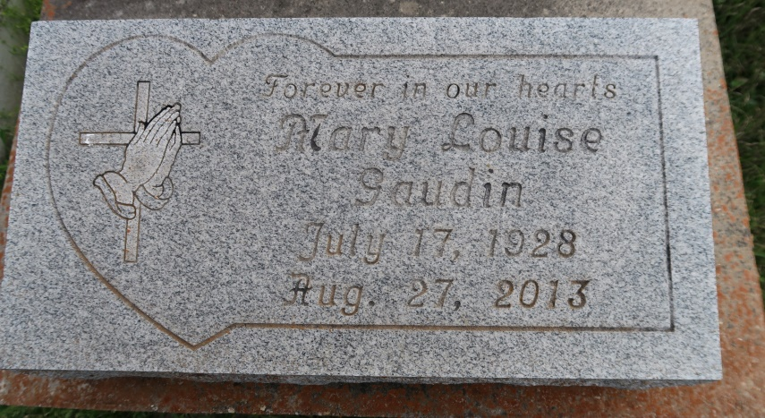

A homemaker and lifelong resident of Convent, LA departed this life on Tuesday, August 27, 2013 6:16 am at The Carpenter's House in Baton Rouge, LA. She was 85 years old.
Visitation at St Michael's Catholic Church, Convent, LA on Tuesday ,Sept 3, 2013 from 9am - until Mass at 11 am. Conducted by Father Vincent Dufrense. Interment St Mary Cemetery.
She leaves to cherish her precious memories a loving daughter Agnus (Samarie) Brown and a son Roland (Lorraine) Gaudin, two grandchildren Deja (K'Hartrell) Clark, Cyara Gaudin and a host of other relatives and friends.
Preceded in death by her parents, husband Roland B. Gaudin, a son Anthony Gaudin, a sister Claretta Washington and a brother Eugene Washington, Sr.

Hambrick Family Mortuary, Gonzales, Louisiana

