Perry Luke Gaudin
August 16, 1938 – June 13, 2019

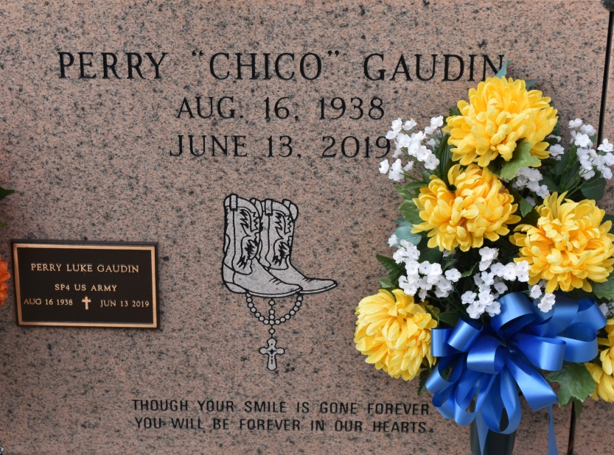

Perry Luke "Chico" Gaudin
A native of Convent and a resident of Paulina. Perry Gaudin passed away at Our Lady of the Lake Regional Medical Center in Baton Rouge on Thursday, June 13, 2019 at 3:30 p.m. He was 80. Visiting at St. Michael's Catholic Church, Highway 44, Convent, Saturday, June 22, 2019 from 9:00 am, until Mass of Christian Burial at 11:00 a.m. celebrated by the Rev. Vincent Dufrense. Entombment in St. Mary's Mausoleum in Convent.
Survived by his wife, Doris Augillard Gaudin. His daughter: Ashley Gaudin. A brother: Ronnie Paul (Audrey) Gaudin. Brothers-in-law: Herman (Sherell), Michael (Hazel), Darryl, Wayne and Leonard (Joyce) Augillard. Sister-in-law: Shirley (Byron) Steib. Nieces, including Natausha Gaudin, Kytara (Cornell) Christophe and Courtney Gaudin, nephews, including Ronnie Paul Gaudin Jr, and Ryan Gaudin. Also numerous cousins, other relatives and friends.
Preceded in death by his parents: Celestin Gaudin and Caldonia Picou Gaudin.
BRAZIER-WATSON IN CHARGE OF ARRANGEMENTS. Visit us at www.brazierwatson.com to sign our guest book.
The Advocate, Baton Rouge, Louisiana
June 19 to Jun. 22, 2019

