Albert Joseph Griffin, Sr.
August 8, 1933 – April 18, 2017

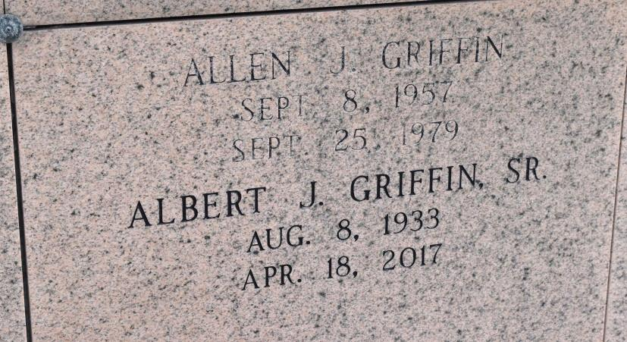

Albert Joseph Griffin Sr., 83, of Bridge City, Texas, passed away on Tuesday, April 18, 2017 at The Medical Center of Southeast Texas, in Port Arthur, Texas.
Albert was born on August 8, 1933, in Lutcher, Louisiana, to parents Gladys (Cotham) and O’Neil Louis Griffin, Sr. He was one of Jehovah’s Witness and an active member of the Kingdom Hall of Jehovah’s Witness in the West Orange Congregation, and the New River Congregation prior. Albert was a veteran of the United States Air Force where he remained in active duty, refueling planes in the field, for 14 years. After receiving his Honorable Discharge from the Air Force, Albert began working as a mechanic for the Sugar Mill, where he retired in 1998. He was a loving husband and partner, to wife Minola (Marquette), for 61 years and a man who dearly loved his family. Albert loved to fish and watch cowboy movies. His grandchildren and great-grandchildren loved being teased by their “Pawpaw” and Albert was famous for his sense of humor.
Preceding Albert in death are his parents; daughter, Christine Zeller Tanner; sons, Allen Griffin and Michael Griffin; sister, Shirley Gauthier; and brothers, Orin Griffin, Vernon Griffin, Wayne Griffin, and Rodney Griffin.
Those who will cherish his memory most are his wife, Minola Griffin; daughters, Cheryl Schaubhut and husband, Doug and Cynthia Rouyea, and husband Chad; sons, Albert Griffin, Jr. and Joseph Griffin, and his wife Christy; sisters, Gloria Herman, Frances Connley, and Gloria Herman; brothers, O’Neil Griffin Jr., Leroy Griffin, and Alfred Griffin; 14 grandchildren and 21 great-grandchildren; and many members of extended family and friends.
A memorial service to remember Albert will be held on Saturday, April 22, 2017 at the Kingdom Hall of Jehovah’s Witness-West Orange at 10:00 AM. The address is 1401 MLKJR, Orange, TX 77630. Arrangements were made under the direction of Dorman Funeral Home.
https://www.dormanfuneralhome.com/obituary/Albert-GriffinSr/services

