Mary Kirby Lea Hawthorne
April 28, 1984 – September 4, 2005

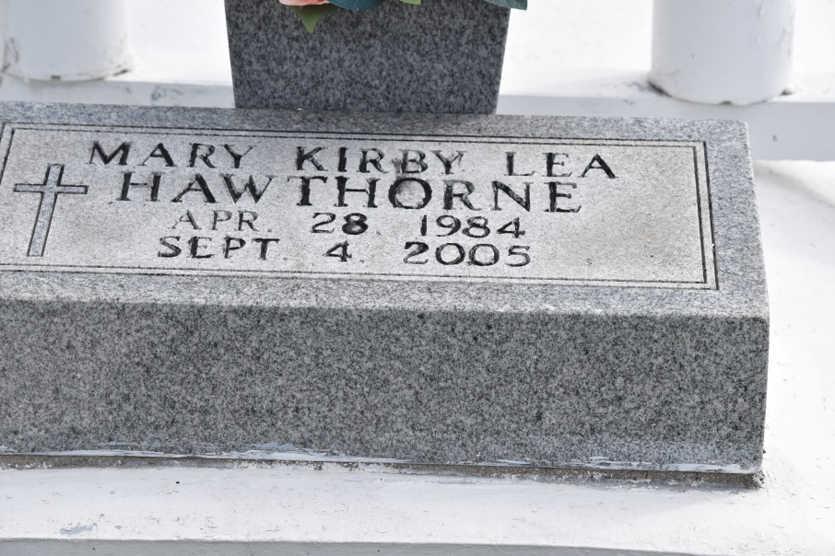

Hawthorne, Mary Kirby Lea "Kirby"
A student at the University of Louisiana at Lafayette and a resident of Convent, she died at 8:22 a.m. Sunday, Sept. 4, 2005, in Lafayette. She was 21 and a native of Baton Rouge. Visiting at St. Michael Catholic Church, Convent, on Saturday, Sept. 10, from 9 a.m. until Mass of Christian Burial at 11 a.m., conducted by the Rev. Patrick Mascarella. Interment in St. Mary Catholic Church Cemetery, Union.
She is survived by her parents, Donald J. Hawthorne and Natalie Dornier Hawthorne; sister, Kerry Hawthorne; maternal grandmother, Alice Joy Dornier; paternal grandparents, Mr. and Mrs. Bobby R. Hawthorne; and numerous aunts, uncles and cousins. She was preceded in death by her maternal grandfather, Raymond Dornier Sr.
Ourso Funeral Home, Gonzales, is in charge of arrangements.
The Advocate, Baton Rouge, Louisiana
Sep. 8 to Sep. 9, 2005.

