Blanche (Andermann) Haydel
August 18, 1925 – July 21, 2002

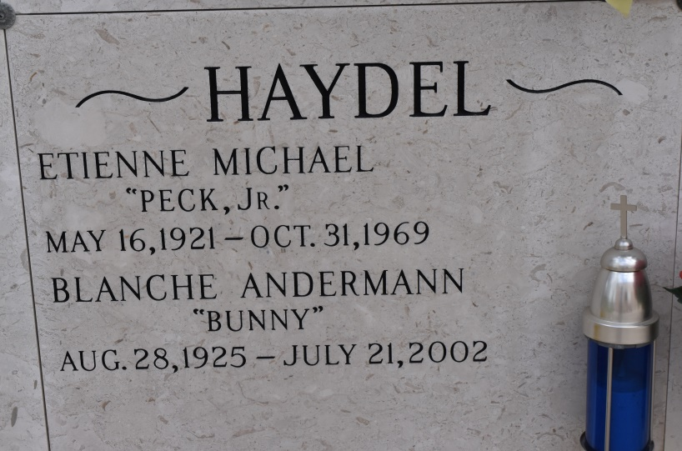

CONVENT – Blanche Andermann “Bunny” Haydel, 76, a native and resident of Union, died July 21. She was the wife of the late Etienne Haydel Jr. and mother of Connie Roussel, Jill Troxclair, Aaron Bourque and Michael, Danny, Dale, Kent, Marty, Troy and the late Patrick Haydel.
She was the daughter of Antoine and Cecile Melancon Andermann and sister of Emily Kernan, Janet Small, Norma Ricca and the late Daniel, Harold and Gilbert Andermann.
She is also survived by 28 grandchildren and six great-grandchildren.
Services are today at noon at St. Michael Catholic Church, Convent, with interment at St. Mary’s Cemetery, Union. Visitation starts at 8 a.m.

L’Observateur, LaPlace, LA
July 24, 2002

