Walter J. Hogg
August 7, 1922 – December 11, 2008

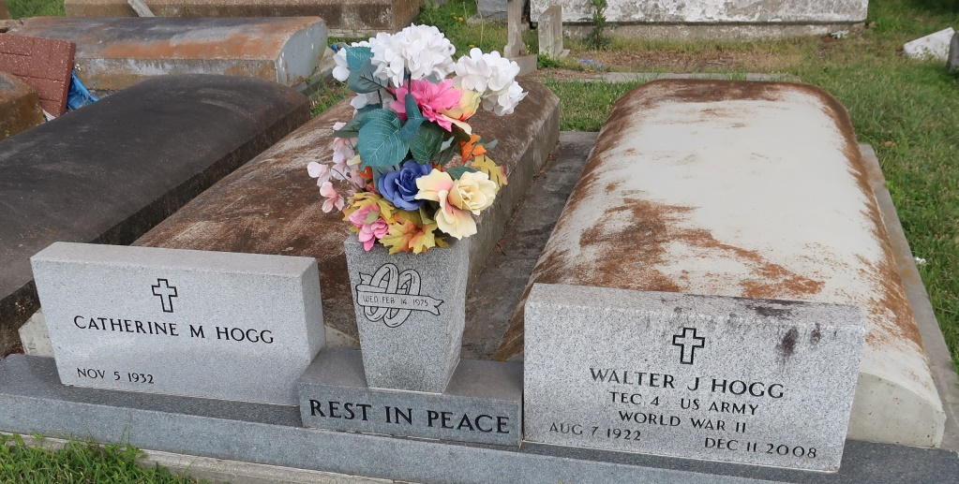

Hogg, Walter J. - resident of Convent and a native of Brooklyn, N.Y., he passed away on Thursday, Dec. 11, 2008 at age 86. He is survived by his wife, Catherine Morel Hogg; three sons, Larry and his wife, Mary Hogg, of Lawrenceburg, Tenn., Wayne and his wife, Earline Hogg, of Petersburg, Va., and Charles Hogg, of Iowa; four stepchildren, 11 grandchildren and eight great-grandchildren.
Preceded in death by his parents, a brother and a sister. He proudly served his country during World War II in the U.S. Army and was a member of the Lutcher VFW and an active member of the Romeville Senior Center.
Visitation at Ascension Funeral Home, 426 W. New River St., Gonzales, on Sunday, Dec. 14, from 5 p.m. to 9 p.m. and again on Monday beginning at 8:30 a.m. Religious services will be held in the funeral home chapel at 10:30 a.m., conducted by the Rev. Michael Galea. Burial will follow in St. Mary Catholic Cemetery in Convent.
The family would like to extend a special thank you to Dr. Albarez, Dr. McCarthy and Dr. Steven Gremillion and the staff of Amedysis Hospice for all of their care and support.
The Advocate, Baton Rouge, Louisiana
December 13 to December 14, 2008

