Louis John Hymel
April 14, 1926 – June 30, 2021

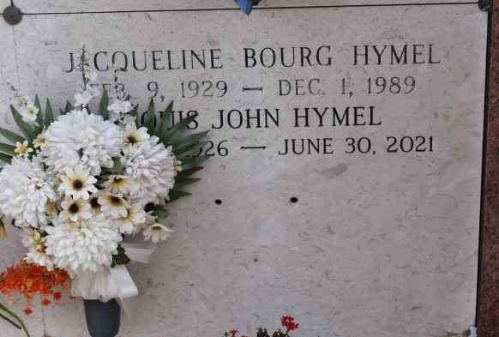

Louis John (L. J.) Hymel died on the 30th day of June, 2021, at 95 years of age. L. J. was born on April 14, 1926. He was a native of Convent, and a resident of Donaldsonville, Louisiana, for the last forty years.
He is survived by his children, Belinda H. Cavell (Danny) of Thibodaux, Becky H. Sotile of Donaldsonville, Louis J. 'Louie' Hymel, Jr. (Kay) of Metairie, Mark S. Hymel (Debra) of River Ridge, Penny H. Weimer (John) of Thibodaux, and Randy P. Hymel (Lisa) of Jackson, MS. He is survived by twenty grand-children: Alaina C. Nugent, Carolyn C. Parfait, Benjamin Cavell, David Cavell, Robert Cavell, Dr. William Cavell, Mark Sotile, Jr., Missy S. Zeller, Matt Sotile, Michelle S. Troxclair, Rebecca S. Knight, Louis J. Hymel, III, JoAnn H. John, William Hymel, Preston Hymel, Chamberlain H. Schwieger, Alexandra Hymel, Jacqueline W. Sanchez, Katherine W. Daigle, and Emily Weimer, together with fifteen great-grandchildren. L. J. is survived by his wife, Gloria B. Hymel, her children, Susie S. Schexnaydre (Jeff), Shelia S. Ashy (Kevin), Sydney S. Morvant (Mark), and their respective families. He is also survived by his brother, Robert F. Hymel (Ollie), of Lutcher, and numerous nieces and nephews.
He was preceded in death by his first wife, Jacqueline Bourg Hymel, his son-in-law, Mark Sotile, Sr., his parents, James I. and Marine Gravois Hymel and his siblings Raymond J. Hymel (Kay), James I. Hymel, Jr. (Marie) and A. C. Hymel (Evelyn).
L. J. was a World War II Veteran and a member of the Veterans of Foreign War, Post No. 5852, Lutcher, Louisiana. He was a sugarcane farmer in Convent, St. James Parish. He served as a member of the Louisiana Farm Bureau, a member of the Ascension Catholic School Board, and an usher at the churches of St. Michael and St. Mary. In addition, he was a committed adorer of the Eucharistic Adoration Chapel at Ascension of the Lord Catholic Church.
Funeral services will be held on Wednesday, July 7, 2021, at Ascension Catholic Church in Donaldsonville. Visitation will be from 9:00 a.m. until funeral time with a Mass of Christian burial at 11:00 a.m. Burial will follow at St. Mary Cemetery in Convent. In lieu of flowers, the family is requesting masses for the Poor Souls in Purgatory or donations to be made to Ascension Catholic Interparochial School at 311 Saint Vincent Street, Donaldsonville, Louisiana70346, or Friends of St. Mary Chapel at
www.saintmarychapel.org or to a charity of your choice.

The Advocate, Baton Rouge, Louisiana
July 3 to July 7, 2021

