Brody Paul Johns
July 10, 1998 – July 7, 2014

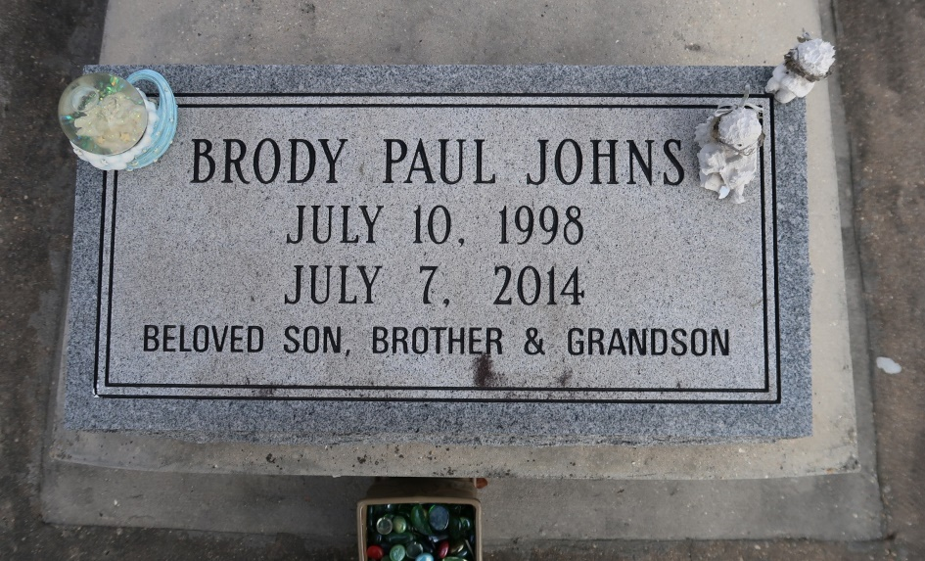

Funeral services will be conducted for Brody Paul Johns, age 15, at 1:00 pm Friday, July 11, 2014 at St. Theresa's Catholic Church with Fr. Eric Gyan and Pastor Randy Smith officiating. Interment will follow at St. Mary's Cemetery in Convent, Louisiana. Visitation will be held Friday from 10:00 am until service time at St. Theresa's Catholic Church.
A resident of Gonzales, Brody passed away at 8:02 pm on Monday, July 7, 2014 at his residence. Brody had a big heart. He was a student at St. Amant High School where he was a member of the Wrestling Team and the FFA. He was an avid hunter and fisherman; he loved animals and never met a stranger. He will be deeply missed by all who knew and loved him.
He is survived by his mother, Kelli Waguespack; father, Cody Wayne Johns; brother, Parker Wayne Johns; grandparents, Richard & Myrtle Waguespack, Deborah & Herman Castete; Godparents, Blake Prejean & Joanie Prejean; aunts and uncles, Ami Brunson, Jason Ward Johns, Kelly Castete, Pam and Mike Straub, Paula and Steve Morris, Katie and Seth Rains, Adrian Waguespack and JoAnn, Mike and Vicki Waguespack, Rhonda and John Gaughan, George Waguespack, Bonnie and Randy Simpson; special cousin, Spencer Brunson and close family friends, John Genet, Holly Arthur, Lindsey Spriggs and Mason Arthur. He was preceded in death by his grandfather, Kindell Wayne Johns. Pallbearers will be Cordell Decuir, Jace Chiquelin, Glenn Keaton, Spencer Brunson, Edmond Rachal and Garrett Rachal.
In lieu of flowers, donations may be made to St. Jude's Children's Research Hospital. To view on-line obituary, video tribute and sign the guest register, please visit www.oursofuneralhome.com. Ourso Funeral Homes of Gonzales is in charge of arrangements.
Advocate, The (Baton Rouge, LA)
Wednesday, July 9, 2014
Contributed by Jane Edson

