Irma M. (Benn) Johnson
June 13, 1918 – July 2, 2002

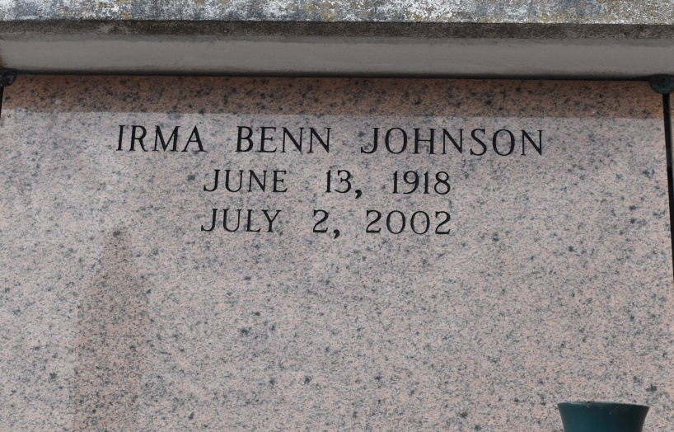

Irma M. Johnson, a homemaker, died Tuesday of respiratory failure at Touro Infirmary. She was 84. Mrs. Johnson was born in Convent and lived in New Orleans for the past 60 years. She was a parishioner of Holy Ghost Catholic Church and was a member of its Senior Citizen Center and Sodality.

Survivors include a son, Andrew Thompson of Convent, and a daughter, Katherine Darville.

A Mass will be said Saturday at 10 a.m. at Holy Ghost Catholic Church, 2015 Louisiana Ave. Visitation will begin at 9 a.m. Burial will be in St. Mary Cemetery in Convent. Majestic Mortuary is in charge of arrangements.
Times-Picayune, The (New Orleans, LA)
Thursday, July 4, 2002
Contributed by Jane Edson

