Melishia (Lewis) Johnson
February 1, 1938 – December 28, 2015

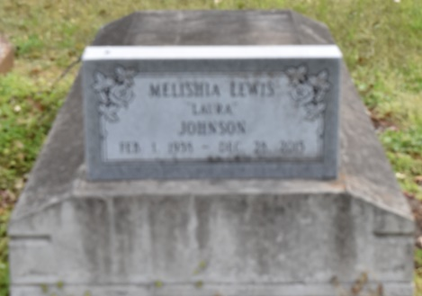
Melishia L. Johnson was born on February 1, 1938 to the parentage of Eddie Lewis, Jr and Roseanna Smith Lewis in Burnside, LA. She was the 3rd child of eleven. Melishia accepted Christ at an early age in Convent, LA at Jeremiah Baptist Church, and served under the late Rev. J. Saul, Rev. Clarence Alvis and Rev. Joseph White, Sr. until her death. She was a faithful member of the choir and church secretary until her illness no longer allowed.
She was called home to rest on Monday night Dec. 28, 2015. Visitation will be on Saturday, January 2, 2016 at Jeremiah Baptist Church, Convent, LA from 9 am until 11 am service time. Conducted Rev Joseph White. Interment Phillipian Cemetery (sic).
Melishia leaves to cherish her memory (7) seven siblings Audrey M Lewis, Sorrento, LA McKinley Lewis (Stella), Joe (Eula) Lewis, Andrew (Shirley W.) Lewis, Lionel (Shirley H) Lewis all of Gonzales, LA; Roseanna Lewis, Theresa L. Paul both of Sorrento, LA; a sister-in-law Zerdia Lewis, Gonzales, LA; a son Dwayne A. (Catherine N.) Wilson of Baton Rouge, LA; two grandchildren Joshua and Jermiquec of Baton Rouge, LA one uncle, Henry Smith (Ida) of Gonzales, LA; five Godchildren: Bobby L Smith, Darry L Raven, Veronica Lewis, Johnny Diggs and Courtney Dominique and a host of nieces, nephews, other relatives and friends.
She was preceded in death by her Parents Eddie and Roseanna S. Lewis, Husband, Clarence Johnson, daughter Tara Densie Johnson, one sister Anna L. Raven, one brother-in-law Dave Raven III, two brothers Eddie and George Lewis, one nephew and two nieces. Melishia was a lover of crafts, crotchet and knitting for her family and friends.

The Advocate, Baton Rouge, Louisiana
Dec. 30, 2015 to Jan. 2, 2016.

