Theresa (Roberts) Jumonville - Guion
January 26, 1881 – August 17, 1951

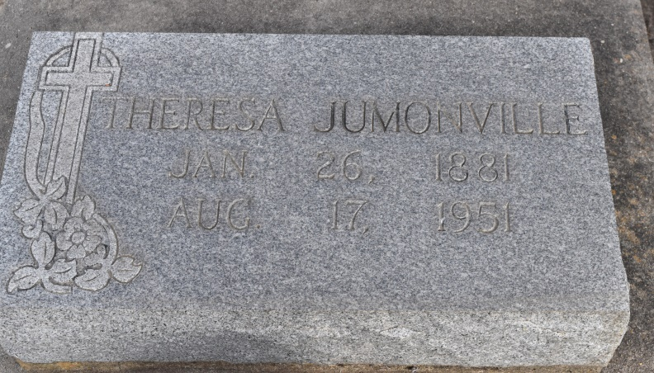
GUION - In Union, La., on Friday, August 17, 1951, at 9:40 o'clock a.m., Theresa Jumonville Guion, beloved wife of Frank Guion; mother of Mrs. Victor Poirier of Union, La., Mrs. Paul Delery of New Orleans, La., Joseph Jumonville of Baton Rouge, La.; sister of Mrs. Sarah Pirenton, Mrs. Louis Dembrun of New Orleans, La., Mrs. Anna Aucoin of Franklin, La. and Joseph Robert of New Orleans, La.; also survived by five grandchildren, and six great-grandchildren; aged 70 years, 5 months and 9 days.

Relatives and friends of the family are invite to attend the funeral, which will take place from the residence of Mr. Victor Poirier of Union, La., at 8:45 o'clock a.m. Religious services at St. Mary's Catholic church, Union, La., at 9 o'clock a.m. Interment in St. Mary's Catholic cemetery, Union, La. Landry-Daigle-Montz in charge of arrangements.
Times-Picayune, New Orleans, Louisiana
Saturday, August 18, 1951, p. 2, col. 7

