Evelyn (Hotard) Labat - Meche
August 28, 1920 – April 1, 2003

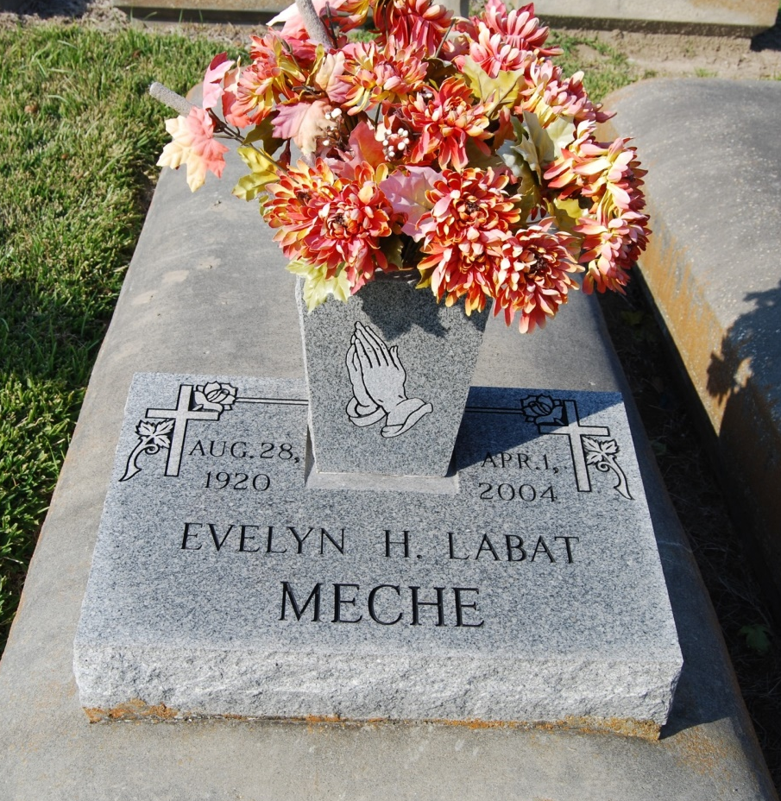
Photo by Kerry Keller

MECHE, EVELYN HOTARD LABAT - A retired Goudchaux's Main Street employee and a resident of Baton Rouge, she died Thursday, April 1, 2004, at Landmark of Baton Rouge. She was 83 and a native of Union. Visiting at St. Jude Catholic Church from 9 a.m. Monday until religious service at 10 a.m. Interment in St. Mary Cemetery, Union, at 1 p.m. Monday. Survived by two nieces, Cindy Cabler and Rosie Smith; two nephews, Jim Borne and Billy Borne; and a sister-in-law, Wilma Meche. Preceded in death by first husband, Eddie Labat; second husband, Raymond Meche; sister, Gertrude Hotard Borne; and a brother, June Hotard. Rabenhorst Funeral Home East, 11000 Florida Blvd., in charge of arrangements.
Advocate, The (Baton Rouge, LA) - Sunday, April 4, 2004
Contributed by Jane Edson

