Amita J. (Louviere) Landry
June 28, 1934 – April 9, 2012

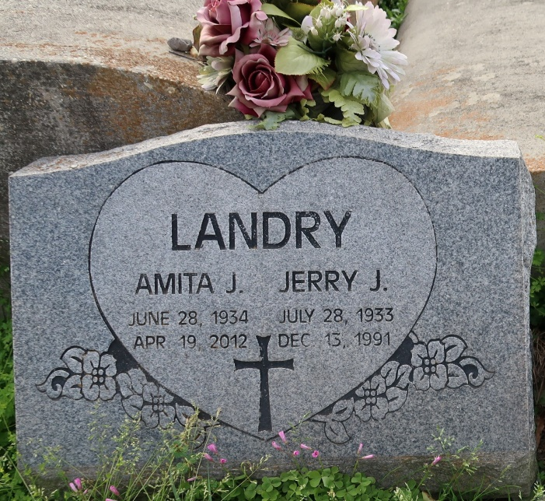
Amita J. Landry, native of New Iberia, and resident of Convent, La, passed away on Monday, April 9, 2012 at the age of 77. She is survived by her daughter and son-in-law, Cheri and Peter Graugnard; six sons and daughters-in-law, Jerry and JoAnn Landry, Billy and Patty Landry, Dennis and Lorraine Landry, Adam Landry, Glenn Landry, and Daniel and Kelly Landry; 18 grandchildren; and 16 great-grandchildren. She was preceded in death by her husband, Jerry Landry; and parents, Adam and Marie Bonin Louviere.

Visitation will be held at St. Michael Catholic Church on Thursday, April 12, from 9 am until Mass of Christian burial at 11 am, conducted by Fr. Vincent. Burial will follow in St. Mary Catholic Cemetery.

The family would like to give a special thanks to Dawn, Shelly, and all of St. Joseph's Hospice for their love and care.
Advocate, The (Baton Rouge, LA)
Wednesday, April 11, 2012
Contributed by Jane Edson

