Ada Bernadette (Schexnaydre) Louviere
July 17, 1906 – November 6, 2005

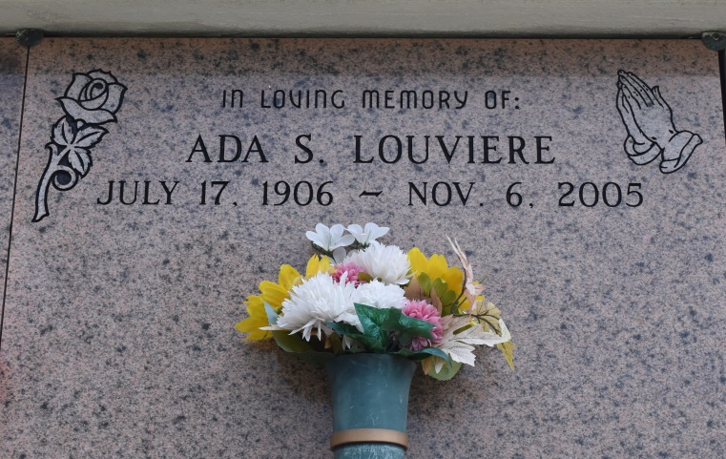

A resident of Convent, she died Sunday, Nov. 6, 2005, at 11:30 a.m. at Tangi Pines Nursing Home in Amite. She was 99 and a native of Brusly. She was the beloved wife of the late Edmond J. Louviere Sr.; beloved mother of Martha Jane Wooddall, Mary Sheets, Edmond J. "T-Poke" Louviere Jr. and the late Dianne Blanchard; mother-in-law of Bill Wooddall, Shirley Louviere and the late Aubrey Sheets; grandmother of Pam Bordelon, Chad and Rodney Louviere, Derek Sheets, Robert Wooddall and Stacey LeBiche; and great-grandmother of Ken, Kelsie, Caid, Kyleigh, Rachael, Robert, Corey and Brandon.
She also was preceded in death by three sisters, a brother, and her parents, Albert and Eva Schexnaydre.
Relatives and friends of the family are invited to attend the funeral Mass at St. Michael's Catholic Church, Convent, on Thursday, Nov. 10, at 11 a.m. Visitation at the church on Thursday after 9 a.m. until funeral time. Entombment in St. Mary's Mausoleum, Union. H.C. Alexander Funeral Home, Lutcher, is in charge of arrangements.
The Advocate, Baton Rouge, LA
November 9, 2005, Sec A, Pg 20, Col 4
Contributed by Jay Schexnaydre

