Rita June (Bergeron) Magnitzky
June 13, 1932 – January 16, 2009

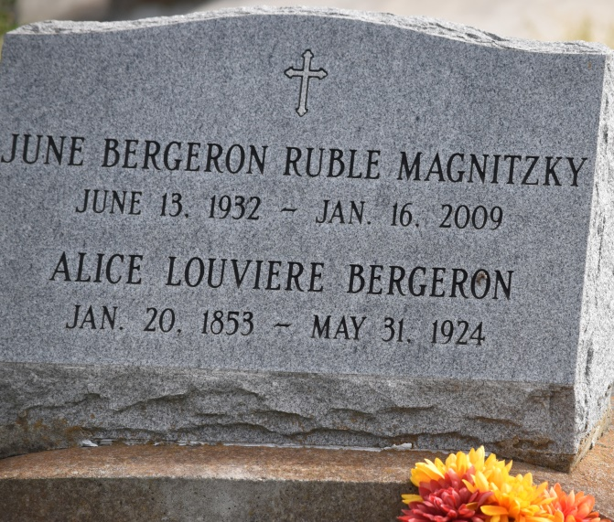

Rita "June" Bergeron Magnitzky, age 76, a resident of Denham Springs, passed away on Friday, January 16, 2009 at Golden Age Nursing Home. A native of Union, she was a retired nurse.
She is survived by her daughter, Rene Smith of Denham Springs; two sons, John Ruble of San Diego, Calif. and Howard Ruble of Pensacola, Fla.; two sisters, Helen Boudreaux of Union and Elaine Lane of Tyler, Texas; eight grandchildren and three great-grandchildren.
She was preceded in death by her husband, Ivan A. Magnitzky; her parents, Henry and Jeanne Letulle Bergeron; a son, Floyd "Buddy" Ruble; and an infant brother.
Visitation will be at Ourso Funeral Home in Gonzales on Wednesday, Jan. 21 from 11 a.m. until time for at 2 p.m. in the funeral home chapel. Burial will be in St. Mary's Cemetery in Union.
Daily News, The (Bogalusa, LA)
Wednesday, January 21, 2009
Contributed by Jane Edson

