Jeannie (Giamalva) Massi
April 7, 1914 – January 28, 2005

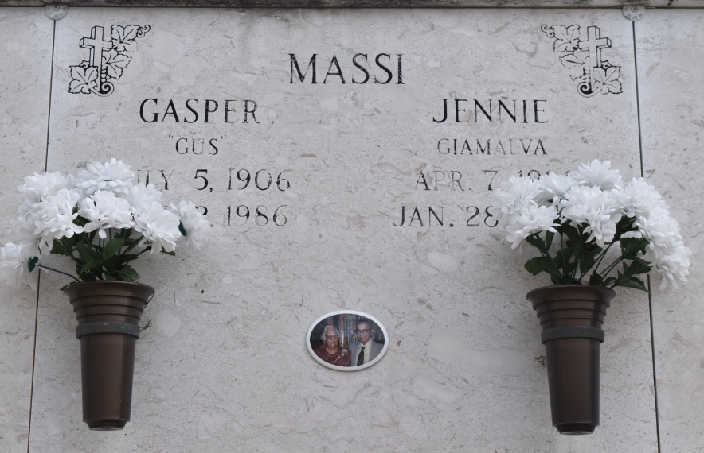

Jennie Giamalvia Massi - A homemaker and resident and native of Convent, she died Friday, Jan. 28, 2005, in Gonzales. She was 90. Visiting at Ourso Funeral Home, Gonzales, from 5 p.m. to 9 p.m. Sunday, Jan. 30. Visiting at St. Mary's Catholic Church, Union, from 8 a.m. until religious service at 11 a.m. Monday, Jan. 31. Entombment in church mausoleum.
She is survived by two daughters and sons-in-law, Anna Massi Laiche and Gerald Massi, Sorrento, and Josephine Massi Alford and Johnnie Alford, Convent; two sons and daughters-in-law, Michael John and Gloria Massi, Independence, and Natanial G. and Dorothy Massi, LaPlace; a sister, Mary G. Bua, San Jose, Calif.; brother, Michael Giamalvia; 24 grandchildren, Michael and Brian Pruett, Jarad and Tiffany Crotwell, Christy Massi, Jonathan and Jacob Massi, Chelsea, Hailey and Travis Deweese, Victoria Bessonet, Braden Small, Anthony Massi, David Massi, Pamela Laiche Crotwell, Veronica Massi, Jeffery Massi, Kevin Pitre, Elizabeth Laiche Deweese, Kelly Pitre Small, Christopher Massi and Jennifer Massi, Heather Alford and Jennifer Massi; four stepgreat-grandchildren, Brooke Bercegeay, L.J. Massi, Macie Stokes and Marcie Freeman; and a great-great-granddaughter, McKenzie Mayer.
She was preceded in death by parents, Natale and Josephine Noto Giamalvia; husband, Gasper G. Massi; four sisters and two brothers.
Pallbearers will be Anthony, David and Jeffery Massi, Kevin P. Pitre, Jeron Crotwell and Travis Deweese. Honorary pallbearer is Michael Pruitt.
Special thanks to her loving caregiver, Margie Dorsey.
Advocate, The (Baton Rouge, LA)
Sunday, January 30, 2005
Contributed by Jane Edson

