Andrew McKinley
July 7, 1929 – September 6, 2001

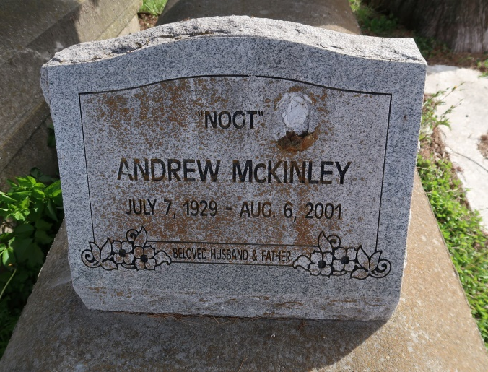

Andrew "Noot" McKinley Sr., a retired machine operator, died Monday of leukemia at East Jefferson Hospital. He was 72. Mr. McKinley was born in Convent and lived in Lutcher for the past two years. He was a former employee of CMI Construction in Convent.
Survivors include his wife, Karen Taylor; seven sons, Andrew Jr. of Paincourtville, Larry, Randolph, Anthony, Carl, Lester and Dedricke McKinley, all of Lutcher; nine daughters, Dianne Adams, Debra, Leshia, Lillian, Orelia McKinley and Lorrine Love, DeAndra Stewart, Asharria and Akyrria McKinley, all of Convent; a stepdaughter, Ashantia Taylor; a sister, Lillian Melancon; and 40 grandchildren.
Services will be held Friday at 10 a.m. at St. Michael Church in Convent. Burial will be in St. Mary's Cemetery in Union. Hobson Brown Funeral Home handled arrangements.
Times-Picayune, The (New Orleans, LA)
Thursday, August 9, 2001
Contributed by Jane Edson

