Gertrude Cecile (Chauvin) Melancon
March 12, 1919 – November 25, 2018

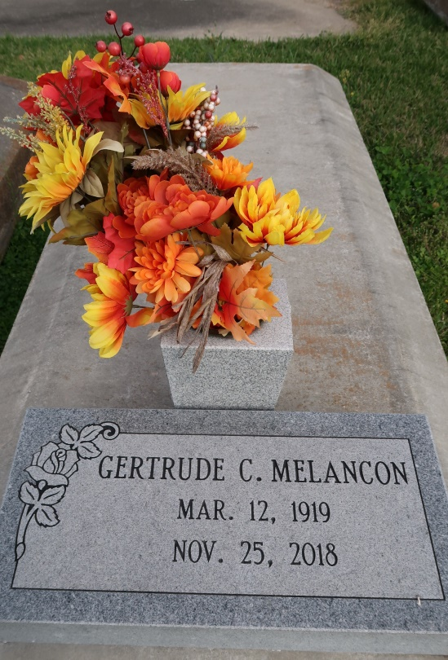
Gertrude C. Chauvin Melancon, a native of Union and resident of Prairieville, LA passed away Sunday, November 25, 2018 at the age of 99. Gertrude will be remembered for her love of her family especially her grandchildren. She was devoted to her catholic faith.
She is preceded in death by her husband Milton Melancon; parents, Philip and Aglae Chauvin; Siblings, Philip Jr., Wilbert, Maurice, Andrew, Lynn, Adolf, Albert and Vivian Chauvin.
She is survived by a daughter, Sandra Brown (Dudley); two sons, Donald Melancon, Jeffrey Melancon (Cindy); grandchildren, Michelle Bourque, Monica Langlois, Brandon Brown, Melissa Verdigets, Christopher Melancon, Dianna Dicioccio, Daron Melancon, Jordan Melancon and Brooke Melancon ; 13 great-grandchildren and numerous nieces and nephews.
Family and friends are invited to attend a visitation which will be held Tuesday, November 27, 2018 at St. John the Evangelist Catholic Church from 9:30am - 11:00 am followed by the Mass of Christian Burial at 11:00 am. The burial will immediately follow in St. Mary's Cemetery in Union, LA.
The family would like to thank the staff at Pinnacle Hospice especially Brittney, Nikki, Brent and Annette for their outstanding care and compassion.
Please visit www.oursofh.com to leave expressions of sympathy and condolences. Ourso Funeral Home, Gonzales is in charge of arrangements.
The Advocate, Baton Rouge, Louisiana
Nov. 25 to Nov. 27, 2018

