Mary Ann (Sarazin) Melancon
September 15, 1918 – July 1, 2003

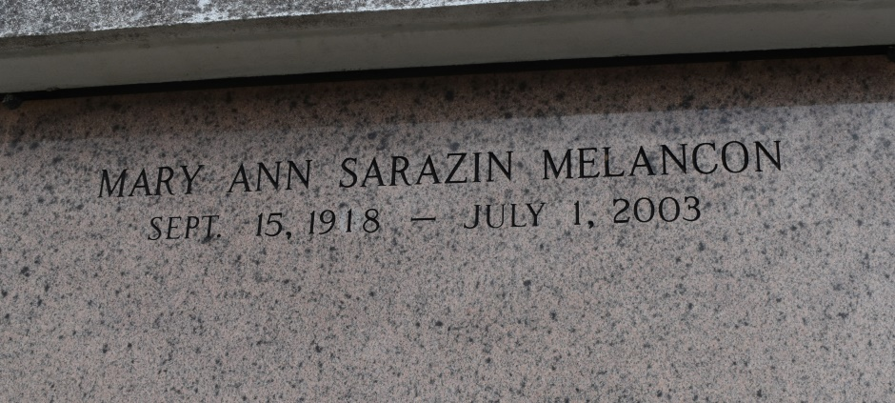
Mary Ann Sarazin Melancon - A retired former employee of the Blue Runner canning factory in Gonzales, she died at 10:45 a.m. Tuesday, July 1, 2003, in New Orleans. She was 84, a resident of New Orleans for the past six years and a native and longtime resident of Union.
Entombment in St. Mary's Catholic Church Mausoleum, Union. Survived by a daughter, Rita Mire, Gonzales; two sons, Francis Melancon, Baton Rouge, and Floyd Melancon, Gonzales; a sister, Mary Louise Porta, New Orleans; seven grandchildren and six great-grandchildren.
Preceded in death by her husband, Claiborne J. Melancon; parents, Willie and Ada Dubourg Sarazin; and numerous brothers and sisters.
Pallbearers were Eric Melancon, Gary Melancon, Wade Mire, Ralph Cadow, Eric Cadow and Joe Hotard. Honorary pallbearers were Capt. Douglas Burruss and Richard Terrebonne.
Gonzales Weekly Citizen, Ascension Parish, Louisiana
Monday, July 14, 2003
Contributed by Jane Edson

