Laure Marie Mire
December 10, 1899 – December 31, 2001

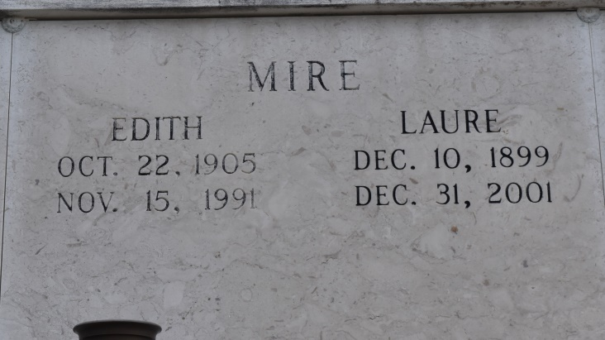
UNION - Laure Marie Mire, 102, a native of Central and resident of Gonzales, died Dec. 31. She was the daughter of the late Ernest and Adine Melancon Mire and sister of Amelie Nobile and the late Regina Hymel and Aline, Edith, Lydia, Clothile, Adela and Clovis Mire. She is survived by six nieces and four nephews.
She was a retired clerk at Hymel Grocery Store with 60 years of service.
Services were Jan. 2 at St. Mary Chapel, Union, with interment at the church cemetery.
L'Observateur, St. John the Baptist Parish, Louisiana
Tuesday, January 8, 2002
Contributed by Jane Edson

