Fred Louis Mitchell, Jr.
July 19, 1926 – April 3, 2006

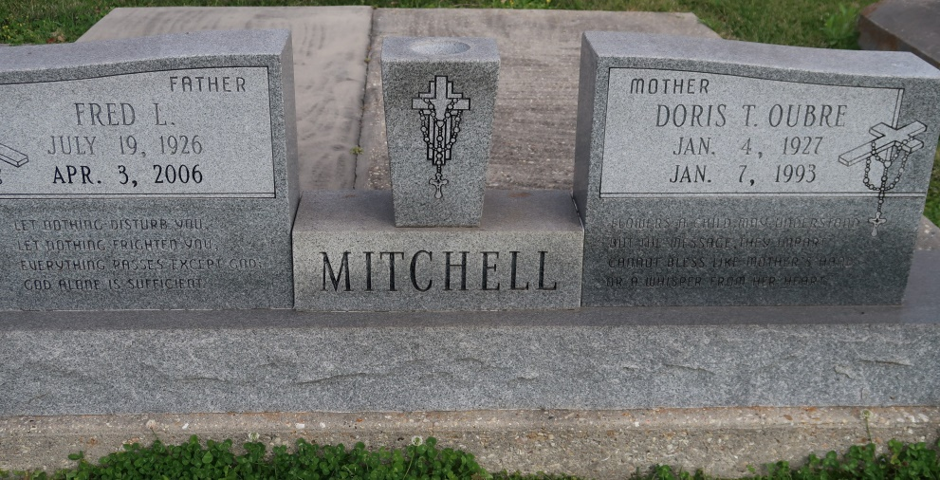
A retired Louisiana State Police officer with Troop A and a resident of Convent, he was entrusted to God's care on Monday, April 3, 2006, in Thibodaux. He was 79 and a native of Burnside.
Mr. Fred was a U.S. Navy veteran of World War II, having served on the USS Nashville off the shores of the Philippines under Gen. Douglas MacArthur.
Visitation at St. Mary's Catholic Chapel, Convent, on Friday, April 7, from 10 a.m. until Mass of Christian Burial at noon, with the Rev. Ed Fuss, celebrant. Interment in the church cemetery.
He is survived by two daughters and sons-in-law, Dale and Bobby Mire, Convent, and Karen and Jimmy Jones, Gonzales; two sons and daughters-in-law, Nathan and Sharon Mitchell, Donaldsonville, and Morris and Tanya Mitchell, Gonzales; two sisters and brothers-in-law, Rose Lee and Godfrey Waguespack, Gonzales, and Doris Ann and Guy Poche, Lutcher; eight grandsons, a granddaughter, three great-granddaughters and two great-grandsons.
Preceded in death by his wife, Doris Oubre Mitchell; mother, Victoria Cox Mitchell; and father, Fred Louis Mitchell Sr.
Pallbearers will be Glen Mire, Daniel Mitchell, Jared Jones, Luke Mitchell, Butch Waguespack and Beaux Poche. Honorary pallbearers are Joseph Mire, Shawn Jones, Cory Mitchell, Keith Mitchell and Guy Poche Jr.
He was an equipment manager at LSU under Dr. Marty Broussard and was an avid LSU and Yankees fan. He will always be remembered mostly for his amazing memory of sports statistics. Arrangements by Ourso Funeral Home, Donaldsonville.
The Advocate, Baton Rouge, Louisiana
Apr. 5 to Apr. 6, 2006

