Amelie (Mire) Nobile
October 9, 1909 – March 12, 2011

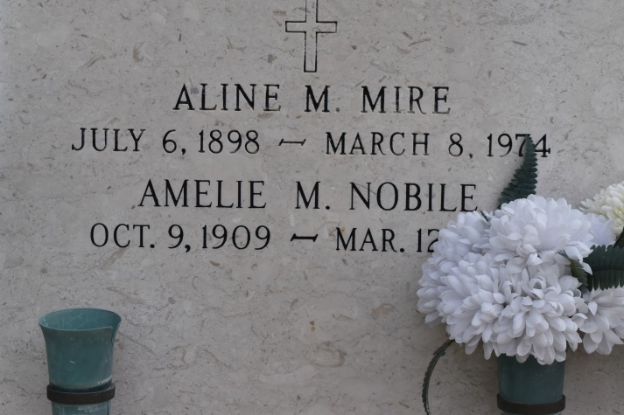
Amelie "Mel" Mire Nobile, 101, passed away Saturday, March 12, 2011. She was a resident of Gonzales and a native of Central. She was preceded in death by her husband, Felix P. Nobile; parents, Ernest and Adine Melancon Mire; brother, Clovis Mire; sisters, Aline Mire, Laure Mire, Regina M. Hymel, Edith Mire, Lydia Mire Mire, Clothile Mire, and Adela Mire. She was a retired V&M Motors employee and past choir member at St. Mary Church.
Visitation at St. Michael Catholic Church, Convent, on Monday, March 14, from 9 a.m. to 10:45 a.m., followed by a Mass of Christian Burial at 11 a.m. Burial in St. Mary Church Cemetery in Union.
Her family would like to thank Azalea Estates, Life Source Hospice and Ascension Oaks Nursing and Rehabilitation Center for the loving care of Ms. Mel.
Arrangements by Rose Lynn Funeral Services. To sign and view the family guest book, please visit www.roselynnfuneralhome.com.
The Advocate, Baton Rouge, Louisiana
March 13, 2011.

