Edgar J. Picou
July 28, 1934 – October 17, 2008

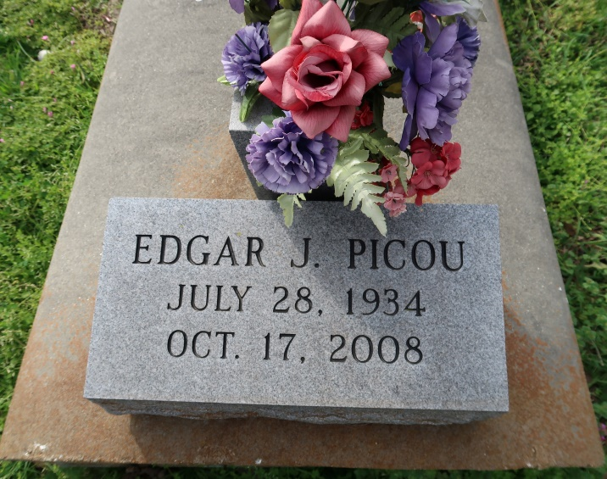
A resident of New Orleans, he died Friday, Oct. 17, 2008, at Canon Hospice. He was 79 and a native of Convent.

Visiting at St. Michael the Archangel Catholic Church, Convent, on Thursday, Oct. 23, from 9:30 a.m. until religious service at 11 a.m. Interment in St. Mary Cemetery, Convent.

Survived by a brother, Clarence Picou Jr.; nieces, Jennifer and Jacqueline; nephews, Rawlin, Timothy and Gerald; devoted friend, Beverly Watterson; and godchildren, Kaysha and Kristen.

Preceded in death by his parents, Clarence and Olivia Picou.

He was a member of Knights of Peter Claver Counsel 159. Arrangements by Baloney Funeral Home, LLC, Garyville.
Advocate, The (Baton Rouge, LA)
Wednesday, October 22, 2008
Contributed by Jane Edson

