Leola (Dumas) Picou
October 27, 1921 – December 11, 2008

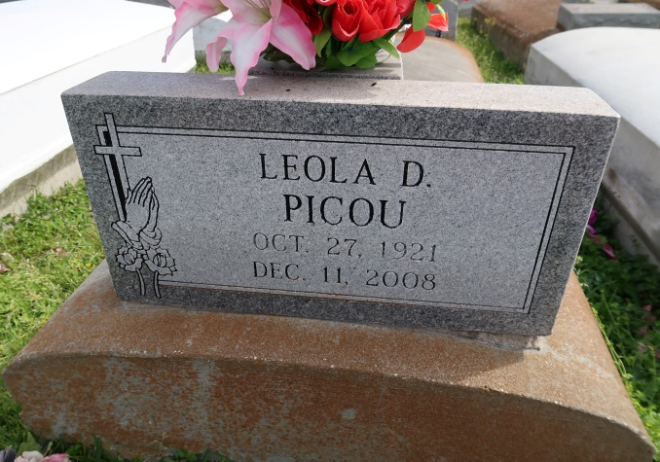
Leola D. Picou, 87, passed away on the snowy morning of Thursday, Dec. 11, 2008, at D'Ville House in Donaldsonville. She was a resident of Convent.
Survived by her children, Lucille Dillworth, of Kenner, Sharon Lomas, of Gonzales, Ray Picou and wife Shirley, of Darrow, Claude "Herbert" Scott, Dianne Robinson, Jo Ann Picou, Osborne Jr., Gail Picou, and Jerome Picou and wife Yolanda, all of Convent; sisters, Beverly Allen and husband Roy, of Convent, Florence Ainey, of New Orleans, and Mickey Melancon, of Baton Rouge; brother, Joseph Dumas Jr. and wife Camille, of Headland, Ala.; 19 grandchildren, 38 great-grandchildren and nine great-great-grandchildren. She is also survived by a host of nieces, nephews, cousins and friends, four godchildren and a devoted niece-in-law, Rosalie Gaudin, of Gonzales.
Visitation at St. Michael's Catholic Church, 6476 La. 44, Convent, on Saturday, Dec. 20, from 8:30 a.m. to 10:45 a.m., followed by a Mass of Christian Burial at 11 a.m. Interment in St. Mary's Cemetery in Union. Members of the St. James Parish Council, Sheriff's Office ABM, Motiva Terminal, Ponchartrain Levee Board, St. James Parish school system, Chevron Super Stop and Jefferson Community Action Head Start are all invited to attend funeral services.
She was preceded in death by her husband, parents, five siblings, five sisters-in-law and four brothers-in-law. Arrangements by Lawson-Rollins Purple Shield Funeral Home of Gonzales.
Advocate, The (Baton Rouge, LA)
Friday, December 19, 2008
Contributed by Jane Edson

