Verna M. (Jones) Picou
November 14, 1910 – September 25, 2002

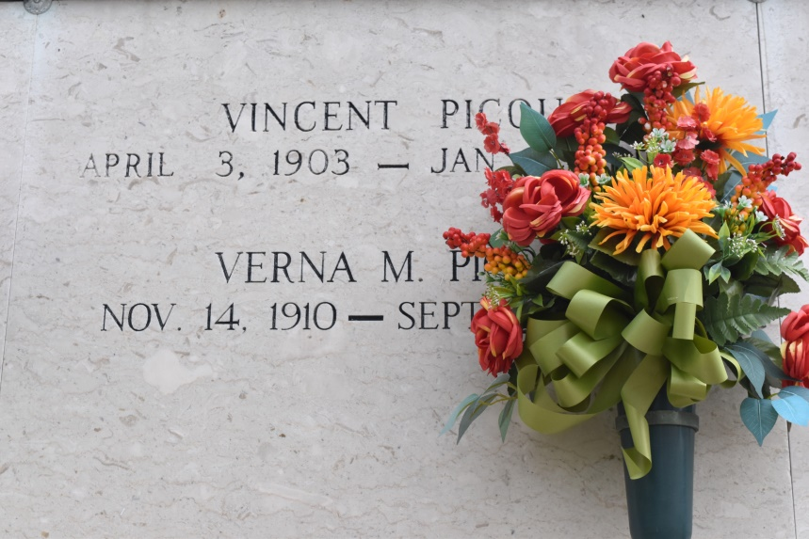
Verna Jones Picou at Ascension Hospital, Gonzales, La., at 11:15 A.M., Wednesday, September 25, 2002. Daughter of the late Joseph Jones and Priscilla Washington Jones. Wife of the late Vincent Picou. Sister of the late Melba Banks, Evelyn Ellis, Wilhemina Benn, Mildred Cola, Rita Jones, and Rosie Ellis and Gerald, Milton, Herman and George Jones. Sister in law of Stella Jones of Convent, La., and Nelson Ellis of Gonzales and Joseph Jones of Vacherie, La. Also survived by a number of nieces, including, Betty Hayes, of Convent, La., nephews, cousins, other relatives and friends. Age 91.

Visiting at St. Mary's Catholic Church, Convent, La., Monday, September 30, 2002 from 9:30 A.M. until Mass of Christian Burial at 11:00 A.M. Recitation of the Rosary at 10:30 A.M. Entombment in St. Mary's Mausoleum, Convent, La. In lieu of flowers, Masses preferred. Brazier-Watson Funeral Home in charge of arrangements.
Times-Picayune, The (New Orleans, LA)
Sunday, September 29, 2002
Contributed by Jane Edson

