Victoria Picou
October 24, 1868 – January 9, 1948

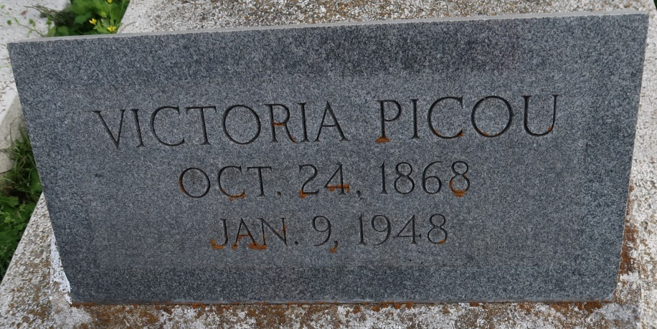
PICOU - On Friday, January 9, 1948, at 11 o'clock p.m. at the residence, Central, La., Mrs. Victoria Picou, beloved mother of Mrs. Bertha Melancon of Ferriday, La., Leontine Stewart, Caldonia Gaudin and Vincent Picou, sister of Mrs. Louise Joseph. Deceased is also survived by 37 grandchildren and 55 great-grandchildren, aged 79 years, 2 months and 13 day, a native and resident of Central, La.

Relatives and friends of the family also officers and members of St. Peter Benevolent Association, are respectfully invited to attend the wake on Sunday at the residence, Central La., and funeral on Monday, January 12, 1948, at 9 o'clock a.m. Religious services at St. Mary Chapel at Union, La. Interment in St. Mary cemetery, Union, La. Serviced by Hobson Brown Funeral Service, Garyville, La.
Times-Picayune, The (New Orleans, LA)
Monday, January 12, 1948, p. 3

