Bernardine (Chauvin) Poche
May 20, 1942 – December 26, 2006

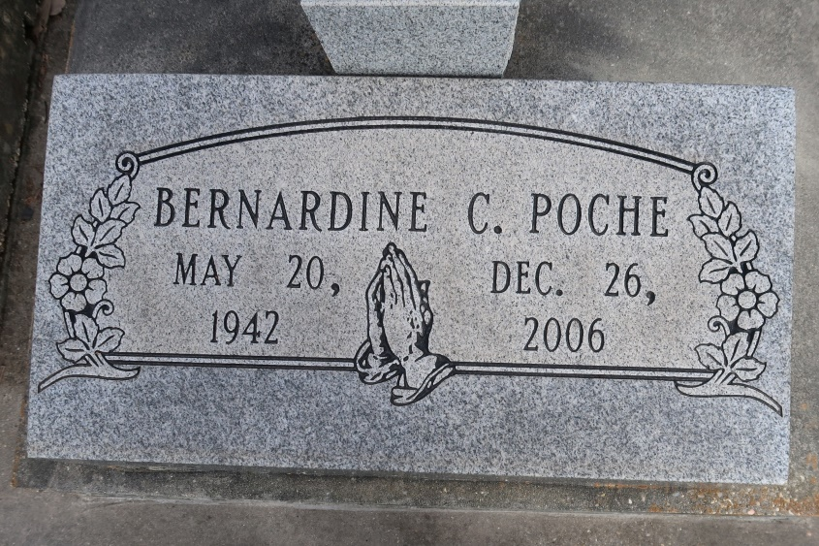
Poche, Bernardine Chauvin "Bernie" - A loving wife, mother and grandmother, she died Tuesday, Dec. 26, 2006, at 7 p.m. in Baton Rouge. She was 64, a resident of Baton Rouge and a native of Union.
Visiting at St. Mary Catholic Church, Union, on Friday, Dec. 29, from 9 a.m. until religious service at 11 a.m. Interment in the church cemetery.
She is survived by her husband, Emile Poche Jr., Baton Rouge; two sons and daughters-in-law, Randy Paul Poche and Monique Bourgeois Poche of Wilbur-by-the-Sea, Fla., and John Phillip Poche and Patricia Hoff Poche of Baton Rouge; daughter and son-in-law, Amy Poche Gallagher and Glenn Gallagher of Kennesaw, Ga.; and six grandchildren, Michelle Poche, Amelia Gallagher, Allison Gallagher, Catherine Gallagher, Brianna Poche and Chandler Poche.
She was preceded in death by her parents, Andrew Chauvin and Georgine Chauvin; and brother, Miller Paul Chauvin. Arrangements by Alexander Funeral Home, Lutcher.
The Advocate (Baton Rouge, LA)
December 28, 2006

