Mary Louise (Sarazin) Porta
August 10, 1911 – March 4, 2006

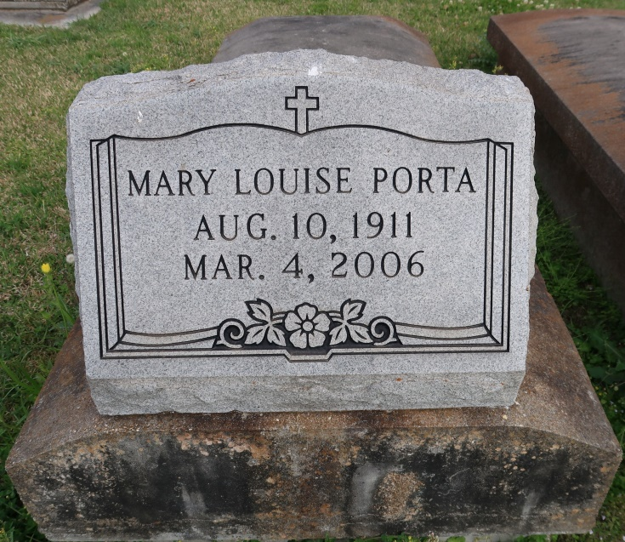
Mary Louise Sarazin Porta - A homemaker and a resident of New Orleans, she died at 2:30 p.m. Saturday, March 4, 2006, in New Orleans. She was 94 and a native of Union.
Visiting at St. Mary's Chapel, Union, on Tuesday, March 7, from 9 a.m. until Mass of Christian Burial at 11 a.m., with the Rev. Frank Uter, celebrant. Interment in the church cemetery.
She is survived by three daughters, Mary Jane Porta Babin, Gonzales, Katherine Porta Terrebonne, River Ridge, and Doris Ann Porta Cadow, New Orleans; two sons, Warren D. Porta Jr., Gonzales, and Daniel A. Porta, St. Amant; 24 grandchildren, 13 great-grandchildren and three greatgreat-grandchildren.
She was preceded in death by her husband, Warren D. "Boone" Porta Sr.; parents, Willie and Ada Dubourg Sarazin; two daughters, Faye Porta and Mary Ellen "Pye" Porta Dragg; four sisters, Mary Ann Sarazin Melancon and Dinah, Annie and Rita Sarazin; and two brothers, Hypolite and John Sarazin.
Advocate, The (Baton Rouge, LA)
Monday, March 6, 2006
Contributed by Jane Edson

