Ian Kantrell Robertson
May 18, 1981 – September 14, 2014

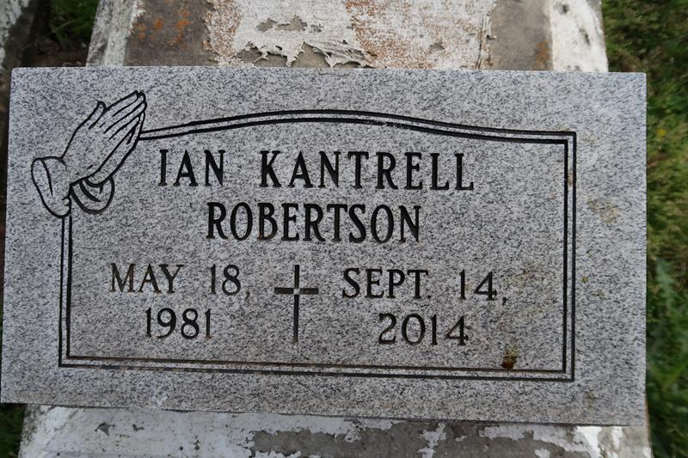

Lutcher man fatally shot Sunday in LaPlace
A 33-year-old Lutcher man was fatally shot early Sunday at Revere and Essex drives in LaPlace, the St. John the Baptist Parish Sheriff's Office said.
Ian Robertson, who was taken to River Parishes General Hospital, died at 1:35 a.m., the sheriff's office said. That was about an hour after the office received the call about the shooting, which was the sixth homicide in the parish this year.
An autopsy is scheduled for Sunday. According to the sheriff's office, detectives said they have neither suspects nor a motive.
Anyone with information about the case may call the St. John Parish Sheriff's Office TIPS line at 985.359.TIPS or Crimestoppers at 504.822.1111.
People who call Crimestoppers do not have to testify and may qualify for a reward. They also can submit tips to the sheriff's office website at http://stjohnsheriff.com/submitatip.php.
Times-Picayune, The: Web Edition Articles (New Orleans, LA)
Sunday, September 14, 2014
Contributed by Jane Edson

