Dianna Theresa (Picou) Robinson
January 23, 1950 – March 25, 2021

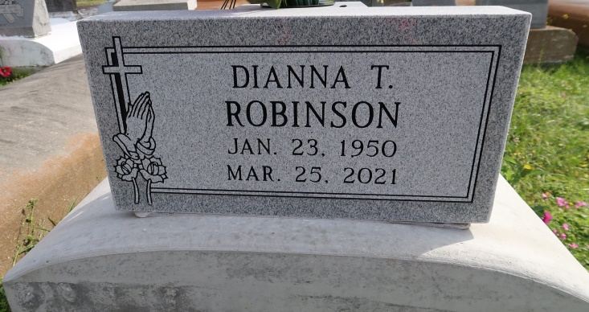
Surrounded by love, Dianna Theresa Picou Robinson, known as (T Da), passed away at the rightful age of 71 at her home in Convent, LA on March 25, 2021. She was a native and longtime resident of St. James Parish, residing in Convent, LA. While obtaining her education she attended Cypress Grove in Lutcher, LA. A faithful and dedicated worker of the workforce, Dianna was employed by Motiva for 10 years. She was a dedicated sister, aunt, friend, babysitter and so much more to us. Love was always shown to everyone she met over the years.
While showing love and falling in love she married the late Joe Robinson. From their union they were blessed with one son, Terron Kentrell Robinson, Sr. She is survived by her son, Terron Kentrell Robinson, Sr.; four grandchildren, Terrion Johnson, Ty'Rionne Fredericks, Terron Kentrell Robinson, Jr. and Tyron Robinson; sisters, Geneva Robinson, Relelie (Lillie) Rogers, Lucille Dillworth, Claudette Scott (Herbert Sr.), JoAnn Picou, Sharon Lomas, and Gail Picou; brothers, Osborne Picou, Jr., Ray Picou ( Shirley), and Jerome Picou (Yolanda); uncle, Joseph Dumas, Jr.; aunt, Beverly Allen; two Godchildren, Herbert Scott, Jr. and Torsha Lomas; special cousin, Rosa Lee Gaudin; friends, Andre Gaines, Stella Johnson, Dwayne Johnson, Gloris Stewart, Yeabu Berner, Shantell Smith and Brendalyn Scott, and a host of nieces, nephews, cousin, other relatives and friends.
She was preceded in death by her mother, Leola D. Picou; father, Osborne Picou, Sr.; husband, Joe Robinson; aunts, uncles and brothers-in law.
A public walk-through visitation will be held on Friday, April 2, 2021 from 4pm-6pm at Treasures of Life Funeral Services, 315 E Airline Hwy, Gramercy, LA 70052. A celebration of life will be held on Saturday, April 3, 2021 at Treasures of Life Funeral Services, 315 E Airline Hwy, Gramercy, LA 70052. Visitation will be from 10am-11am. Service at 11am. Interment to follow at St. Mary Cemetery in Convent, LA. Final care entrusted to Treasures of Life Funeral Services. Due to CDC (COVID-19) guidelines and restrictions, masks and social distancing are REQUIRED!!

Treasures of Life Funeral Services
Gramercy, Louisiana

