Clarence J. Schexnayder
June 11, 1916 – March 29, 1991

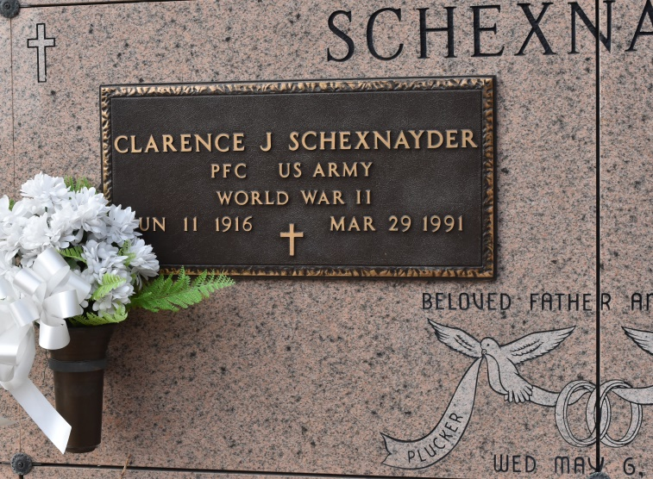
SCHEXNAYDER, CLARENCE J. - Died Friday, March 29, 1991, at Our Lady of the Lake Regional Medical Center. He was 74, a native of Geismar and a resident of Union. He was retired from the Pontchartrain Levee Board and a U. S. Army World War II veteran of the 82nd Airborne Division.
Visiting at St. Mary Catholic Church, Union, 9:30 a.m. until religious services at 1 p.m. Monday, conducted by Father Dick McGuinness. Burial in St. Mary Mausoleum.
Survived by wife, Rose Mae Labat Schexnayder, Union; two daughters, Mrs. Jaynes(Angele) Gandy, Union, and Mrs. Ronald (Grace) Hatcher, Gonzales; a sister, Mrs. Renee (Ophelia) Chauvin, Union; three brothers, L. J. Schexnayder, Sorrento, Percy and Perry Schexnayder, both of Gonzales; three grandsons, Joel Gandy, Justin Hernandez andDaniel Hatcher; and a granddaughter, Kayla Hernandez.
Preceded in death by parents, Ernest and Lillie Louvier Schexnayder; and a sister, Theresa Marie Schexnayder.
He was a member of the American Legion Post No. 171. Alexander Funeral Home, Lutcher, in charge of arrangements.
The Advocate (Baton Rouge, La.)
April 1, 1991, Page: 5-B

