Alcee Paul Schexnaydre
January 23, 1917 – September 6, 1975

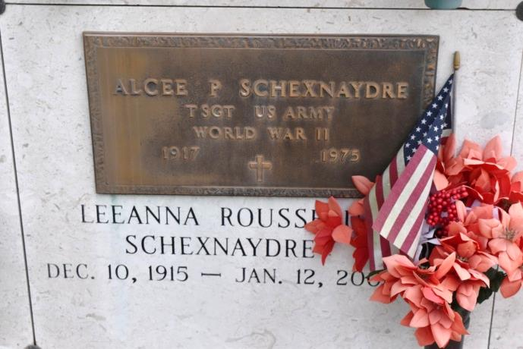
SCHEXNAYDRE, ALCEE P. - Died Saturday, Sept. 6, 1975, at 12:40 a.m. at Our Lady of the Lake Hospital. He was 58, a native of Burnside and a resident of Convent. He was office manager of Helvetia Sugar Co-Op and a World War II veteran.
Body to be at Alexander Funeral Home, Lutcher, from 8 to 11 p.m., Sunday, and from 7a.m. to 9:15 a.m. Monday. Religious services at St. Mary Catholic Church, Union aat 10 a.m., Monday. Entombment in in church mausoleum.
Survived by his wife, Mrs. Lee Ann Rousseau Schexnaydre; one daughter, Cynthia Lee (sista) Schexnaydre, New Orleans; five sons, Ronald Paul Schexnaydre, New Orleans, Barry (Tebe), and Michael (Mike) Schexnaydre, both of Gonzales, David (Boybe) Schexnaydre, and Scott Steven Schexnaydre, both of Convent; five sisters, Miss Bertha Schexnaydre, Miss Effie Schexnaydre, Mrs. Agnes Sim, all of Convent, Sister Mary Martha, O.C.D. (Delia), Jackson, Miss., Mrs. M. C. (Bernadette) Helouin, Baton Rouge; four brothers, Olide, Oliver, Ferducie, and Julien Schexnaydre, all of Convent; three grandchildren.
Preceded in death by a sister Miss Berthil Schexnaydre; and a brother, Henry Schexnaydre Jr.
The Sunday Advocate, Baton Rouge, LA
Sunday, September 7, 1975, p. 24 (4B)

