Glory Marie (Letulle) Schexnaydre
April 16, 1921 – March 2, 2019

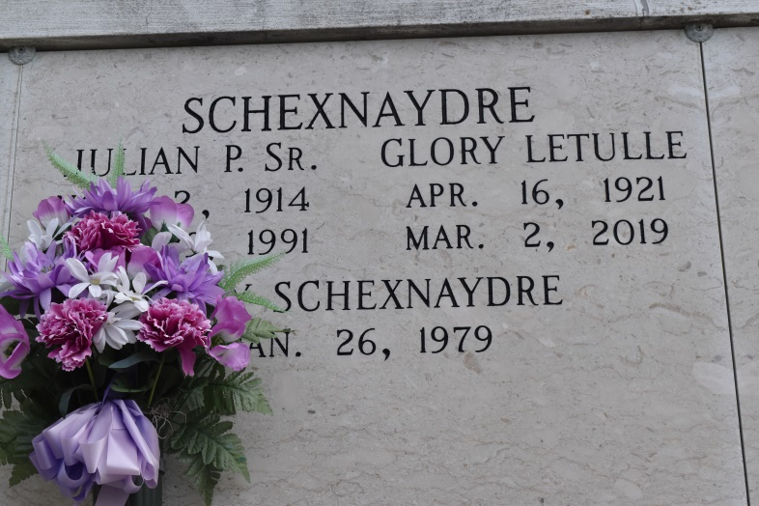
Glory Marie Letulle Schexnaydre, age 97, passed away Saturday, March 2, 2019 in Gonzales at 4:35 a.m. Glory was born April 16, 1921 in the small community of Central in St. James Parish, Louisiana, where she was a lifelong resident. She was the oldest of 10 children in a French-speaking household of her late parents, Ernest Joseph "Campo" Letulle of Central and Roberta Marie Haydel Letulle originally of Edgard. Since her mother had 10 children in 14 years, she learned responsibility at an early age in taking care of her younger siblings, cooking, sewing, and doing yard-work. As a child her father built a wooden box for her to stand on so that she could help her mother cook at the stove, and she enjoyed cooking into her 90s. She attended the White Hall School in Union where she learned to speak English and later graduated from Romeville High School in 1939. The only job she ever held was during WWII when the historic Sacred Heart Convent was converted into a garment factory and she sewed uniforms.
In 1950, Glory married Julian Pierre "Zoo" Schexnaydre Sr. and she moved to Wilton Plantation where her husband and his family farmed sugar cane. As a housewife, she raised her children there before the entire Schexnaydre family relocated 2 miles upriver and established Schexnaydre Lane in 1970 where she resided until she moved into Ascension Oaks Nursing Home in 2013.
A devout Catholic, she said her prayers and the rosary daily. In her later years, she enjoyed making jigsaw puzzles and working in her yard, particularly raking her lawn. She also was devoted to the daily care of Zoo after his numerous surgeries and many multiple-month-long hospital stays.
Glory was preceded in death by her husband, her parents and six of her siblings and their spouses: Wilbert "Frère" Letulle; Maude Chauvin (Wilbert); Grace Tureau Temple (J.D. & Marsette); Robert "Bobby" Letulle (Jacqueline); Dolores Schexnayder (George); Mercedes "De-Deze" Simon (Lawrence) and an infant grandchild.
Glory is survived by her 4 children and their spouses: Julian P. "Junior" Schexnaydre (Cindy) of Burnside; Roberta DuBois (Terry) of Gonzales; Marlene Schexnaydre of Gonzales; Connie Frederic (Patrick) of Union; her 6 grandchildren and their spouses: Jay Schexnaydre of Thibodaux, Todd DuBois (Kristen) of Dutchtown, Meché DuBois of Gonzales, Crystal Matherne (Ernie) of Prairieville, Kip Schexnaydre (Danny) of Houston, Texas and Dirk Schexnaydre of Gonzales; her 6 great-grandchildren: Zoë Rickels, Blair, Brooklyn and Brock Matherne, Lily and Trace DuBois. She is also survived by 3 of her siblings and their spouses: Elta Mae Simon (the late Vincent) of Reserve, Marjorie "Docky" Troxclair (Harrison) of Lutcher; Emile Letulle (Geraldine) of St. Amant.
The family would like to thank Donald Henry for his help and friendship during Glory's years at Ascension Oaks. The care and compassion from the staff at Ascension Oaks will not be forgotten.
The Visitation will be at St. Michael the Archangel Catholic Church on River Road in Convent on Monday, March 4, 2019 from 9:00 a.m. to 10:45 a.m., followed by Mass of Christian Burial at 11 a.m., celebrated by Fr. Alec Sheldon. Entombment in St. Mary Catholic Cemetery Mausoleum in Union.
The Advocate (Baton Rouge, LA)
Mar. 2 to Mar. 4, 2019

