John Henry Schexnaydre
January 12, 1941 – February 6, 2018

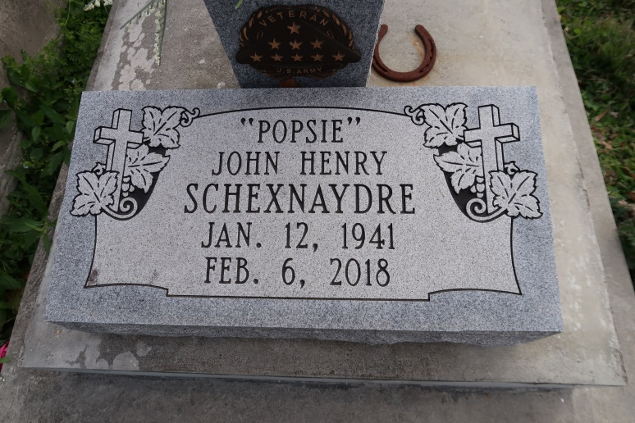

John Henry Schexnaydre, a native of Convent and resident of Springfield, Louisiana, passed away on Tuesday, February 6, 2017 at the age of 77.
He was preceded in death by his parents, Olide and Neva Schexnaydre; late wife, Sylvia Schexnaydre; one son Patrick Henry Schexnaydre and one sister, Mary Ann Schexnayder.
He is survived by his children, John Dean Schexnaydre and Theresa Schexnaydre; 2 sisters, Colette Chauvin (Steve), Adine Hymel (Wayne); 2 brothers, Thomas Shexnaydre (Cheryl), Paul Schexnaydre (Sandy); four grandchildren, Heather Schexnaydre, Holly Schexnaydre, Ian Schexnaydre-Podufalski and Victoria Vick; two great-grandchildren, Wyatt Henry Vick and Ivy Podufalski.
Family and friends are invited to attend the visitation which will be held St. Michael the Archangel Catholic Church on Saturday, February 10, 2018 from 9 am - 11 am. The Funeral Mass will begin at 11am. Burial will follow in St. Mary's chapel Cemetery.
Please visit www.oursofh.com to leave messages of condolences. Ourso Funeral Home, Gonzales in charge of arrangements.
Ourso Funeral Home, Ascension Parish, LA
December 19, 2020

