Leanna (Rousseau) Schexnaydre
December 10, 1915 – January 12, 2008

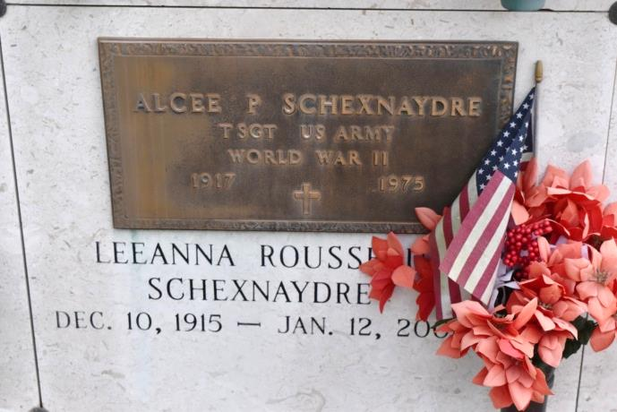
Leeanna Rousseau "Tottie" Schexnaydre - A retired waitress with Hymel's Seafood Restaurant, Convent, she died at 8 p.m. Saturday, Jan. 12, 2008, in Convent. She was 92, a resident of Convent and a native of Belle Rose.
Visiting at St. Michael's Catholic Church, Convent, on Tuesday, Jan. 15, from 8 a.m. until Mass of Christian Burial at 11 a.m., with the Rev. Ed Fuss, celebrant. Entombment in St. Mary's Catholic Church Mausoleum, Union.
Survived by her daughter, Cynthia Lee "Sista" Schexnaydre, River Ridge; five sons and three daughters-in-law, Ronald and Sue Schexnaydre, Slidell, Barry "Tebe" Schexnaydre, Prairieville, Mike and Darlene Schexnaydre, Gonzales, David "Boybe" Schexnaydre, Prairieville, and Scott and Julie Schexnaydre, Gonzales; sister, Alma Rousseau Landry, Paincourtville; nine grandchildren and four great-grandchildren.
Preceded in death by her husband, Alcee Paul Schexnaydre; parents, Marcelin Adler and Adele Marie Dupré Rousseau; a granddaughter, five brothers and seven sisters. Pallbearers will be her grandsons.
In lieu of flowers, please make donations to St. Jude Children's Research Hospital or the American Cancer Society. Arrangements by Ourso Funeral Home, Gonzales.
The Advocate (Baton Rouge, LA)
January 14, 2008 - January 15, 2008

