Lee Louis Schexnaydre, Sr.
November 15, 1923 – January 5, 2014

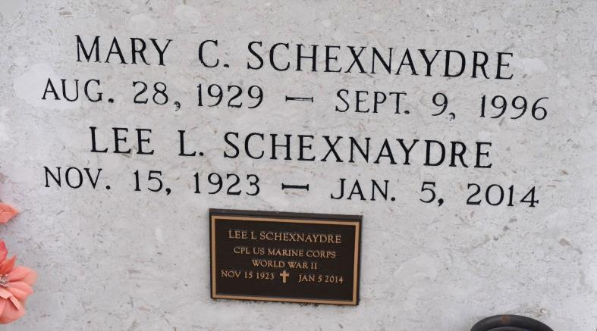

Mr. Lee L. Schexnaydre Sr., of Gonzales, Louisiana, died Sunday, January 5, 2014, in Gonzales. Mr. Schexnaydre was 90 years, 1 month and 21 days old. He was a retired Lab Technician for BASF; a World War II MARINE CORPS veteran (in the Pacific Theater); a charter member of the V.F.W. Post #5852 in Lutcher, Louiciana; a hunter/fisherman; and caring person. Mr. Lee L. Schexnaydre Sr was the son of the late Wildred and Valerie (Waguespack) Schexnaydre. Mr. Schexnaydre was preceded in death by his parents; his beloved wife: Mary (Champagne) Schexnaydre; 5 sisters: Elise (Schexnaydre) Spitzfadden, Clara (Schexnaydre) Abadie, Anne (Schexnaydre) Rocques, Rita Schexnaydre and Lorraine Schexnaydre; 2 brothers: oleus Schexnaydre and Bertin Schexnaydre. He is survived by 4 daughters & 3 sons-in-law: Mary Lee Schexnaydre & Lee Broussard, Patricia & Neal Skinner, Valerie & Keith Schluter and Gerry Schexnaydre, 2 sons & 2 daughters-in-law: Lee Schexnaydre, Jr. & Melinda Wilson and Charles & Melanie Schexnaydre, 10 grandchildren & spouses: Betsy & Derek Paille, Paul Malpass, Chris Malpass, Katie & Jonathan Vignes, Julie Schexnaydre, Lauren Schexnaydre, Alex Schexnaydre, Lee Louis Schexnaydre,III, Courtney Schexnaydre and Stephen Schluter, 2 great-grandchildren: Sam & Hannah Paille; other relatives; and many dear friends. Rosary Mass was held on Tuesday evening, January 7, 2014. Mass of Christian Burial was held on Wednesday morning at St. Michael Catholic Church in Convent, Louisiana. Rev. Brent Maher officiated the services.
Unknown source
*****
Lee Louis Schexnaydre - A native of Burnside and a resident of Gonzales passed away Sunday January 5, 2014 at the age of 90. He was a retired Lab Technician at BASF, a Cpl. in the U.S. Marine Corps serving during WWII in the Pacific Theater. Visitation will be held at Ourso Funeral Home, Gonzales on Tuesday, January 7, 2014 from 6:00 pm until 9:00 pm with recitation of the rosary at 8:00 pm. Visiting will resume on Wednesday, January 8, 2014 at St. Michael Catholic Church in Convent from 10:00 am until a Mass of Christian Burial at 11:00 am celebrated by Rev. Brent Maher. Entombment will follow at St. Mary's Chapel Cemetery, Union, LA. He is survived by 4 daughters & 3 sons-in-law: Mary Lee Schexnaydre & Lee Broussard, Patricia & Neal Skinner, Valerie & Keith Schluter and Gerry Schexnaydre, 2 sons & 2 daughters-in-law: Lee Schexnaydre, Jr. & Melinda Wilson and Charles & Melanie Schexnaydre, 10 grandchildren & spouses: Betsy & Derek Paille, Paul Malpass, Chris Malpass, Katie & Jonathan Vignes, Julie Schexnaydre, Lauren Schexnaydre, Alex Schexnaydre, Lee Louis Schexnaydre,III, Courtney Schexnaydre and Stephen Schluter, 2 great-grandchildren: Sam & Hannah Paille. He is preceded in death by his wife Mary Champagne Schexnaydre, parents: Wilfred & Valerie Waguespack Schexnaydre, 5 sisters: Elise Spitzfadden, Clara Abadie, Anne Rocques, Rita Schexnaydre & Lorraine Schexnaydre & 2 brothers:Oleus & Bertin Schexnaydre. He was a charter member of the V.F.W. Post #5852 in Lutcher. He was an avid hunter and fisherman who enjoyed cooking and spending time with his family.Special thanks to Azalea Estates and their staff for their loving care. You may visit our website at www.oursofh.com to offer condolences to the family.
Advocate, The (Baton Rouge, LA)
Sunday, January 5, 2014
Contributed by Jane Edson

