Mason Klinton Schexnaydre
October 21, 1994 – February 2, 2020

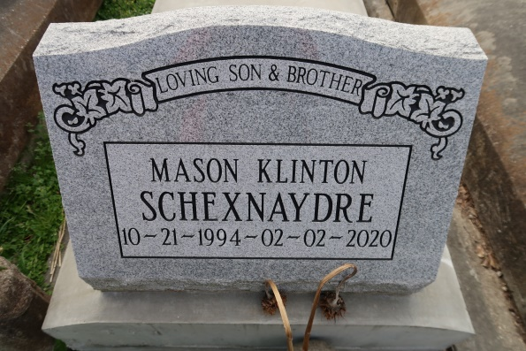

Mason "Fuego" Klinton Schexnaydre, a native of Convent and resident of Geismar, passed away from epilepsy on February 2, 2020 at the age of 25. He is a son, brother, grandson, uncle and friend to many who will be greatly missed. He was a dedicated member of Pi Kappa Theta who enjoyed playing video games, cooking and making everyone laugh. He was kindhearted and would give anyone in need a helping hand! He had a great spirit and always lit up a room with his dancing skills!
He is survived by his parents, Tina Schexnaydre and Brian Young; one sister, Laine Young; maternal great grandmother, Yvette Frederic; maternal grandmother, Gwen Schexnaydre; maternal grandparents, Nathan and Brenda Schexnaydre; paternal grandparents, Danny and Debbie Young; Godparents, Pat and Connie Frederic; and uncle, Brett Young along with a host of cousins and friends.
He is preceded in death by his great grandfather, Leroy Frederic; and great uncle, Clint Frederic. The pallbearers will be Tendrick Cooper, CJ Cherry, Jacob "Bama" Flannagin, Hunter Schexnaydre, Kyle Quebedeaux, Jake Browning, Hunter Townsend, and Jacob Everett.
The honorary pallbearers will be Colin Louque, Anthony Schexnaydre and Brandon Cowell.
The family would like to thank all the first responders of Ascension Parish for their tireless efforts during this time.
Visitation will be held on Tuesday, February 11, 2020 for 10:30 am until the funeral services to begin at 12:00 pm at Healing Place Church in Baton Rouge. Pastor Carter LeBlanc and Pastor Patrick Ramos will be officiating. Burial to follow at St. Mary's Cemetery in Convent,Lousiana.
Ourso Funeral Home, Ascension Parish, LA
December 19, 2020

