Oleus Joseph Schexnaydre, Sr
March 2, 1922 – February 3, 2003

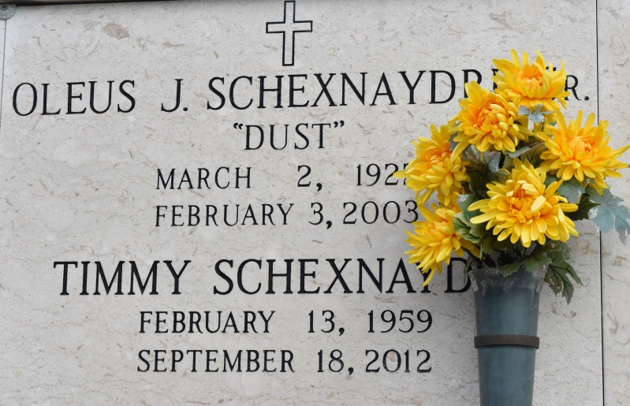

Oleus Dust Schexnaydre Sr. - Born March 2, 1922, in Burnside, Dust passed away Monday, Feb. 3, 2003, at 6:55 p.m. after a lengthy battle with diabetes and congestive heart failure. Oleus was 80.
He leaves behind a son, Timothy Schexnaydre; a daughter, Marie Schexnaydre and friend Janine Hicks; a son and daughter-in-law, Oleus "Rusty" Schexnaydre Jr. and Carla Andermann Schexnaydre; a daughter and son-in-law, Lorain Schexnaydre Landry and Dennis "Poncho" Landry Sr.; two grandchildren, Rheannon Landry and Dennis Landry Jr.; two sisters, Clara Abadie and Anne Roques; and a brother, Lee "Bill" Schexnaydre.
He was preceded in death by his loving wife, Rosa Faucheux Schexnaydre; his parents, Wilfred and Anne Schexnaydre; a brother, Bertin "Booboo" Schexnaydre; and three sisters, Lorraine Schexnaydre, Rita Schexnaydre and Elise Spitzfaden.
He served in the U.S. armed forces and was a veteran of World War II. He was a rice farmer, cattleman, retired sugar cane farmer, an avid fishermen and, most of all, a loving father. He was a member of St. Michael's Catholic Church in Convent.
Oleus was instrumental in starting the first Little League baseball team in Union-Central, and in 1963 brought his team to a championship.
Special thanks to Odyssey Hospice. He will be forever cherished and missed.
Gonzales Weekly Citizen (Ascension Parish, LA)
Wednesday, February 12, 2003
Contributed by Jane Edson

