Rosa Marie (Faucheux) Schexnaydre
January 1, 1924 – September 1, 2001

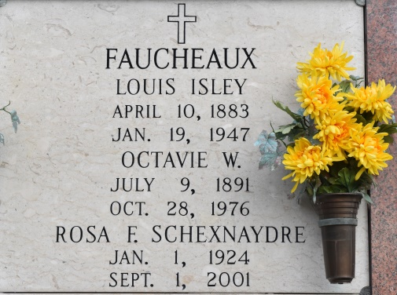

ROSA MARIE FAUCHEUX SCHEXNAYDRE - A resident of Convent and a native of Waggaman, she died at 6:23 a.m. Saturday, Sept. 1, 2001. She was 77. She retired from the Agricultural Stabilization Conservation Service, now known as Farm Service Agency, where she served the farmers of St. James Parish for 38 years. She was an active member of St. Michael's Catholic Church parish fundraising committee, St. Mary's Altar Society and Catholic Daughters of the Americas - Court St. Michael.
Survived by her husband, Oleus Schexnaydre Sr.; two sons, Timothy "Tim" and Oleus Jr. "Rusty" and wife Carla, all of Convent; two daughters, Marie of Gonzales and Mrs. Dennis (Lorain) Landry Sr. of Convent; a step-granddaughter, Rheannon Landry; a stepgrandson, Dennis Landry Jr.; nieces and nephews; and closest and dearest friend, Alice W. Tabor.
Preceded in death by parents, Louis Isley and Octavie Waguespack Faucheux; a brother, Norman Faucheux, who was of Golden Meadow; a half-brother, Roche Faucheux, who was of Norco; and two half-sisters, Mrs. George (Lillian) Gauthreaux, who was of Houma, and Mrs. Clinton (Eunice) Bordelon, who was of New Orleans.
Wake at St. Mary's Chapel, Convent, from 8:30 a.m. Monday until Mass of Christian Burial at 11 a.m. Interment in St. Mary's Cemetery. In lieu of flowers, memorial donations may be made to the American Cancer Society. Welsh Funeral Home, Gonzales, in charge of arrangements.
The Baton Rouge Advocate (LA)
September 2, 2001, Sec D, Pg 10, Col 5-6

