Timothy Jude Schexnaydre
February 13, 1959 – September 18, 2012

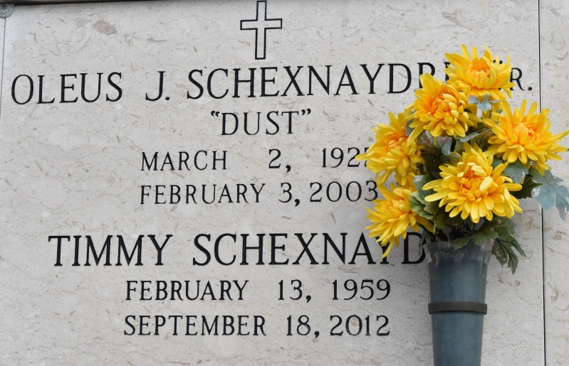

Mr. Timothy J. Schexnaydre, of Baton Rouge, Louisiana, died September 18, 2012. He was 53 years, 7 months, and 5 days old. He was the son of the late Oleus Schexnaydre Sr. and Rosa (Faucheux) Schexnaydre. Mr. Schexnaydre was a zookeeper at the Baton Rouge Zoo, where he worked for 30 years. Mr. Schexnaydre was preceded in death by his parents. He is survived by three siblings, Marie G. Schexnaydre, Rusty Schexnaydre and wife Carla, and Lorain Landry and husband Dennis "Poncho; other relatives; and a host of friends. A memorial service was held at St. Mary's Cemetery in Convent on Friday, September 21, 2012. Fr. Vincent Dufrene officiated the service. He was laid to rest at St. Mary's Mausoleum.
Unknown source
*****
A native of Convent and resident of Baton Rouge, he passed away on Tuesday, September 18, 2012 at the age of 53. His passion for birds led him to his career as a zookeeper at the Baton Rouge Zoo, where he worked for 30 years. He is survived by three siblings, Marie G. Schexnaydre, Rusty Schexnaydre and wife Carla, and Lorain Landry and husband Dennis "Poncho." He was preceded in death by his parents, Oleus Sr. and Rosa Faucheux Schexnaydre. A memorial service will be held at St. Mary's Cemetery in Convent on Friday, September 21, 2012 at 10 a.m., conducted by Fr. Vincent Dufrene. Entombment will follow in St. Mary's Mausoleum. In lieu of flowers, memorial donations may be made to the Humane Society of Louisiana (www.humanela.org/donate.htm). The family would like to extend their deepest appreciation to his extended family at the Baton Rouge Zoo for their help and support. To offer condolences to the family, please visit www.oursofh.com.
The Advocate (Baton Rouge, LA)
Sep. 19 to Sep. 21, 2012

