Floyd Andrew Simon
June 25, 1919 – December 21, 2013

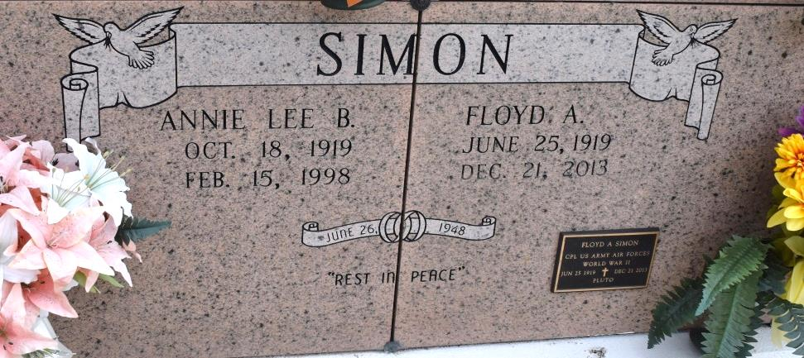

Floyd "Pluto" Simon, age 94, of Lutcher, La passed away on Saturday, December 21, 2013 surrounded by his loving daughters and family. He was the beloved husband of the late Annie Lee Simon. He was the father of five girls; Donna Matte (Donald Sr.), Jolene Bourgeois, Wendy Louque (Kerry Sr.), Sharon Zeringue (Glenn Sr.) and Rhonda Kliebert (Sandy). He is survived by his grandchildren; D.J., Arielle, Brad, Danny Boy, Draper, Raven, Kerry Jr., Kayra, Heather, Glenn Jr., Floyd, Shane and Kiley and his 14 great grandchildren.
He is preceded in death by his parents Prudent Sr. and Olphida Simon and his brothers Prudent Jr., Pelham, Daniel, Neil, Vincent, Lawrence and Allen Simon and his sisters Blanche Poche, Eunice Abadie, Rose Villnerve, Vivian Simon and Pearl Attenhofer.
Floyd was an Army Air Force Veteran of World War II and a member of the VFW Post 5852 and American Legion. He was an active member of the St. James Parish Senior Center and Boat Club. Floyd was a bus driver for St. James Parish School Board and a mail carrier for many years.
Relatives and friends are invited to attend a night wake at H.C. Alexander Funeral Home ,2208 Jefferson Hwy. Lutcher, La on Monday, December 23, 2013 from 6pm-9pm. A visitation will continue on Tuesday, December 24, 2013 from 8am-9:45am. A Funeral mass will be held at St. Joseph Catholic Church in Paulina,La at 10am. Interment will follow at St. Mary's Cemetery in Convent, La. The grandsons will be serving as pallbearers. Condolences may be expressed at www.hcalexanderfh.com.
The New Orleans Advocate (LA)
Dec. 22 to Dec. 24, 2013

