Lawrence Anthony Simon
February 26, 1924 – October 6, 2001

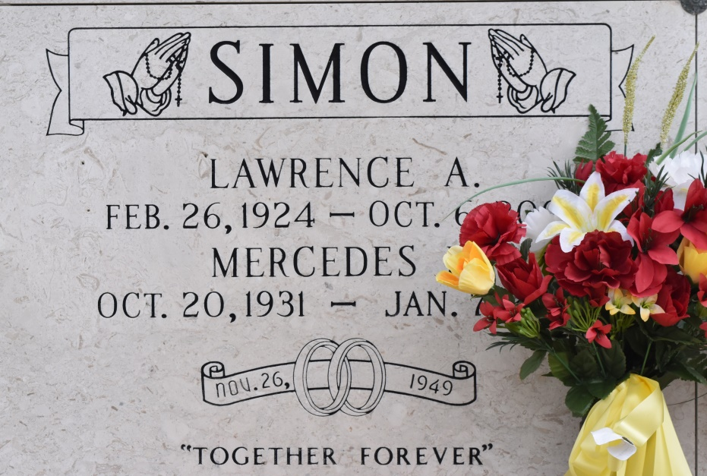

UNION - Lawrence A. Simon, 77, a native of Vacherie and lifelong resident of St. James Parish, died Oct. 6. He was the husband of Mercedes "DeDees" Letulle Simon. He was the son of the late Prudent and Olphida Simon and brother of Allen, Floyd, Neil and Pelham Simon and the late Eunice Abadie, Blanche Poche, Rose Vilnerve, Pearl Attenhoffer and Prudent Jr., Daniel, Vivian and Vincent Simon Sr. Services were Oct. 8 at St. Mary Catholic Church, Union, with interment at the church mausoleum.
L'Observateur (St. John the Baptist Parish, LA)
Wednesday, October 10, 2001
Contributed by Jane Edson

