Lillian (Davidson) Simon
December 30, 1926 – July 25, 2015

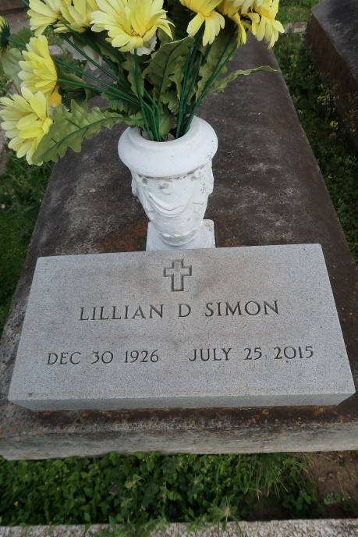

Lillian Davidson Norris Simon, died Saturday, July 25, 2015 at St. Clare Manor in Baton Rouge. She was 88, and a resident of Gramercy, where she was a business owner and longtime dental assistant. She was born December 30, 1926 in New York City to Isabelle and Raymond Davidson, but lived many years with her aunt and uncle, William and Mae Davidson Buras. She owned Wash-O-Mat and Simons Cleaners for 54 years. Her efforts led to the creation of the St. James Parish Library, which she served as board president for 44 years. She did volunteer work for her church and her childrens activities, including serving as PTA president and co-chair of band uniform fund-raising. She was a lieutenant in the Krewe of Rhea, a member of various organizations, and wrote the Over a Coffee Cup column for the News Examiner.
Survived By: Children: Lillie Jantz of Baton Rouge, Nora Adams of Baton Rouge, Sallie Beckes of Pensacola, FL, Jonathan Norris of Grand Point, and lvin Tommy Norris of Gramercy Step-Son: Dr. William C. Norris, Jr. of New Orleans, Sister: Barbara D. Tocci of New York, Brothers: Raymond Snaith (Davidson), of New York; William John DiGiovanni (Davidson) of Kenner, and Bob Davidson of California 7 grandchildren; 13 great-grandchildren; 4 great-great-grandchildren.
Preceded By Spouse: Dr. William C. Norris, Spouse: Pelham Simon, Brother: Richard Davidson, Step-Daughter: Carroll Madigan.
Visitation 9:00 a.m. - 11:00 a.m., Wednesday, July 29, 2015, Most Sacred Heart of Jesus Catholic Church, 616 Main Street, Gramercy, LA, LA 70052. Mass of Christian Burial 11:00 a.m., Wednesday, July 29, 2015, Most Sacred Heart of Jesus Catholic Church; Interment St. Mary Church Cemetery & Mausoleum, Highway 44, Union, LA USA.
Memorial donations may be made to the library or a favorite charity. Rose Lynn Funeral Services, 1870 Cabanose Ave Lutcher, LA 70071, (225) 869-0000.
TheNewOrleansAdvocate.com
July 27 to July 30, 2015

