Mercedes Marie (Letulle) Simon
October 20, 1931 – January 7, 2017

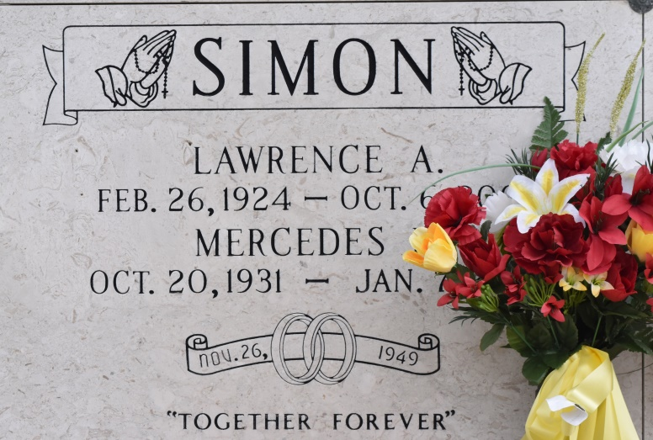

Mercedes L. Simon joined her beloved husband Lawrence A. Simon in Heaven on January 7, 2017.
She is survived by her sisters, Elta Mae Simon, Glory Schexnayder, Grace Temple, Marjorie "Docky" Trosclair, her brother Emile Letulle and a host of nieces, nephews and family members.
She is preceded in death by her sisters, Maude Chauvin and Dolores Schexnayder, her brothers, Robert Letulle and Wilbert Letulle, and her parents, Ernest and Roberta Haydel Letulle.
Relatives and friends are invited to attend a graveside service at St. Mary's Cemetery in Union, LA on Wednesday, January 11, 2017 at 10 AM. Condolences may be expressed at www.HCAlexanderFH.com
The Advocate (Baton Rouge, LA)
Jan. 9 to Jan. 11, 2017

