Neil Ignatius Simon
November 8, 1922 – December 15, 2011

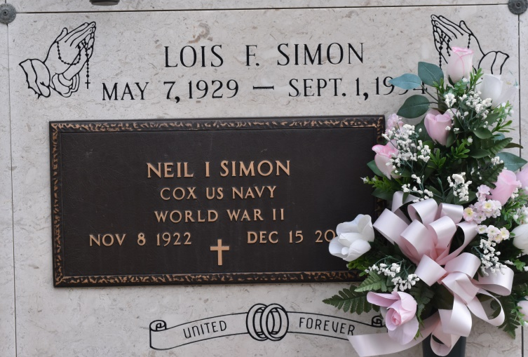

Neil Ignatius Simon - A resident of Convent and a native of Vacherie, he died late Thursday, Dec. 15, 2011. He was 89. He proudly served his country in the U.S. Navy during World War II in the Pacific Theater.
Visitation will be held Saturday, Dec. 17, at St. Michael the Archangel Catholic Church, Convent, from 9 a.m. until Mass of Christian burial at 11 a.m., with the Rev. Vincent Dufresne as celebrant. Burial will follow in St. Mary Cemetery, Union.
Survived by his two daughters and sons-in-law, Mary and Daryl Waguespack and Peggy and Andrew Louque; son and daughter-in-law, Calvin and Ann Simon; brother, Floyd "Pluto" Simon; seven grandchildren, Donovan and Dal Waguespack, Nicole Frazier, Jeremy and Erin Simon, Alicia Jumonville and Drew Louque; and nine great-grandchildren.
Preceded in death by his wife, Lois Frederic Simon; parents, Prudent and Olphida Reider Simon Sr.; five sisters, Vivian Simon, Eunice Abadie, Blanche Poche, Pearl Attenhoffer and Rose Villinerve; and six brothers, Prudent Jr., Daniel, Vincent, Lawrence, Pelham and Allen Simon.
Pallbearers will be his grandsons, great-grandson, Kye Waguespack, and H.J. Goubert Jr.
The family would like to thank the staff at Azalea Estates, where he lived for the past 5 years, for their care and compassion. In lieu of flowers, memorial donations may be made to St. Jude Children's Research Hospital, P.O. Box 1000, Dept. 142, Memphis, TN 38148-0142. To offer condolences to the family, please visit www.oursofh.com.
The Advocate (Baton Rouge, LA)
December 17, 2011

