Pelham Benoit Simon
June 28, 1928 – October 24, 2002

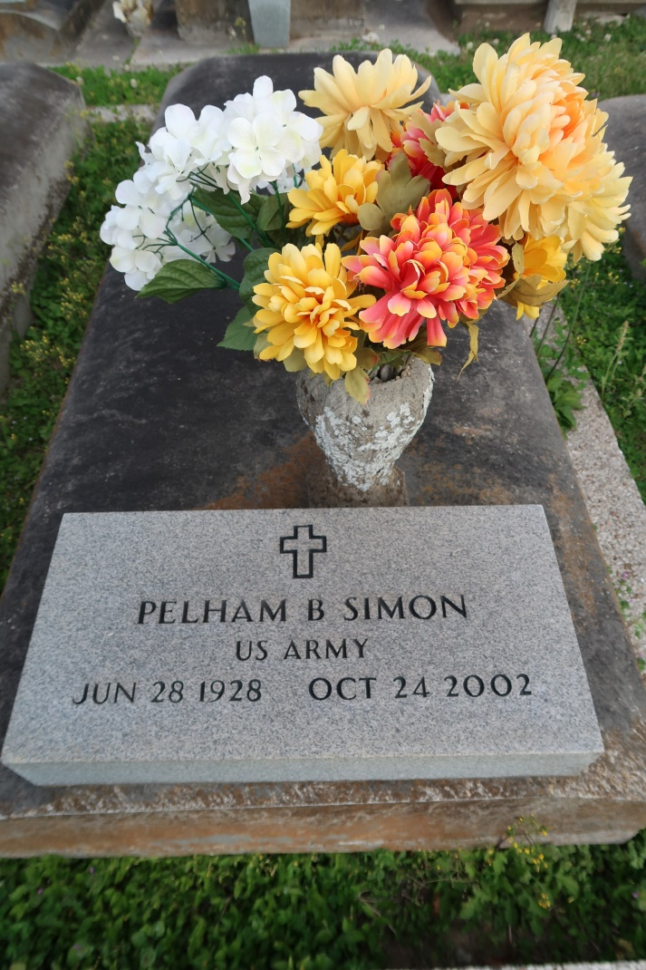

A native and resident of Gramercy, he died 12:10 a.m., Thursday, October 24, 2002 at Ascension Hospital, Gonzales. He was 74. Visitation at St. Mary's Catholic Church, Union, from 8:00 a.m. until 10:00 a.m., Saturday until services at 10:00 a.m., conducted by the Rev. Mario Rizzuto. Interment in St. Mary's Cemetery, Union.
Survived by his wife, Lillian Davidson Simon, Gramercy; three brothers, Allen, Floyd and Neil Simon; stepchildren, Lillie Jantz, Nora Adams, Sallie Beckes, Jonothan and Alvin ''Tommy'' Norris; seven stepgrandchildren, 6 step great grandchildren and numerous nieces and nephews.
He was preceded in death by his parents, Prudent and Olphida Simon; brothers, Prudent Jr., Daniel, Vincent and Lawrence Simon; sisters, Blanche Poche, Vivian Simon, Eunice Abadie, Rose Villnerve and Pearl Attenhoffer.
In lieu of flowers, memorial donations may be made to the St. James Parish Library, 1879 W. Main St., Lutcher, LA 70052 or Cancer Services of Greater Baton Rouge. Special thanks to Dr. Halina and Dr. Gboloo who gave him special care. Also nurses and personnel of Ascension Hospital, St. James Homecare, JoAnn Talley, Jessica Mayeux, Vickey Hunter and last but not least, Bobbie Hicks. Mrs. Simon said that without these wonderful people, she would not have made it. She wishes everyone to have her everlasting thanks and prayers. Arrangements under the direction of H.C. ALEXANDER FUNERAL HOME, 2208 JEFFERON WHY., LUTCHER, LA. Information: 225-869-5553

Published by The Times-Picayune (New Orleans, Louisiana)
Oct. 25 to Oct. 26, 2002.

