Rosalba (Gaudin) Smith
September 9, 1906 – November 25, 2001

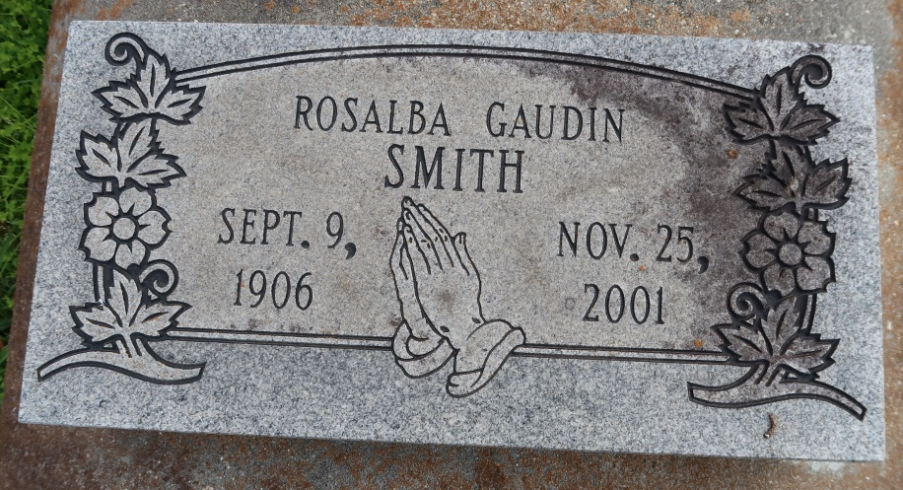

Rosalba Gaudin Smith - A resident of Convent, she died at 2 a.m. Sunday, Nov. 25, 2001, at Ascension Hospital, Gonzales. She was 95 and a native of Darrow.
Visiting at St. Mary's Catholic Church, Convent, the Rev. Mario Rizutto, pastor, from 10 a.m. Wednesday until Mass of Christian Burial at 11 a.m., the Rev. Joseph Rodney, S.S.J., celebrant. Burial in church cemetery.
Survived by two stepdaughters, Mae Adams, California, and Katie Ruth Carr, New Orleans; a stepson, David Smith, New Orleans; and numerous stepgrandchildren, nieces, nephews, cousins, other relatives and friends.
Preceded in death by her parents, Adolph Jeanbatiste "Batiste" Gaudin and Rosalba Darensbourg Gaudin; husband, George Smith; three brothers, Celestain, Ronald and Reynold Gaudin; and six sisters, Adolphine Sidney, Kerney Gaudin, Deasmer Porche, Iantha Benn, Oneda Barrow and Parrine Caldwell. Brazier-Watson Funeral Home in charge of arrangements.
The Advocate (Baton Rouge, LA)
Tuesday, November 27, 2001
Contributed by Jane Edson

