Edna (Guidry) St. Pierre
November 11, 1916 – January 25, 2015

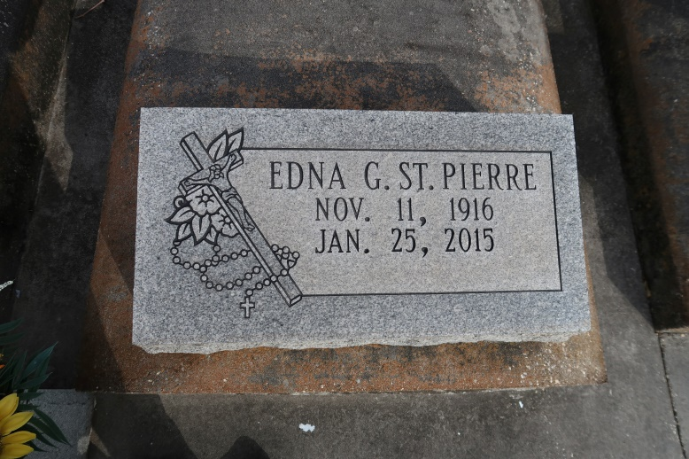

Edna Guidry St. Pierre passed away on Sunday, January 25, 2015 at 4:10 pm at Nottingham Nursing Home in Baton Rouge, LA at the age of 98 years old. She was a resident of Gonzales, LA and a native of St. James Parish, LA.
Visiting at St. Mark Catholic Church, Gonzales, LA on Wednesday, January 28, 2015 from 9 am until Mass of Christian Burial at 11:00 am conducted by Rev. Rubin Reynolds. Interment in St. Mary Catholic Cemetery in Covent, LA.
Survived by her daughter and son-in-law, Rowena and Alvin Chauvin; son and daughter-in-law, Leroy J. and Nettie St.Pierre; seven grandchildren, Travis Chauvin, Brandon Chauvin, Dannette Duplessis, Yvonne Watts, Randall St.Pierre, Belinda Cook and Keith St.Pierre; eight great-grandchildren, one step great-grandchild, four great-great-grandchildren and three step great-great-grandchildren.
Preceded in death by her husband, Norris J. St.Pierre; grandson, Ralph St.Pierre; parents, Wilford and Ada Guidry; sister, Viola Jumonville; brother, Adam Guidry. Pallbearers will be Travis Chauvin, Brandon Chauvin, Randall St.Pierre Keith St.Pierre, Grant Duplessis and Pete Decoteau. She was a member of St. Mark Catholic Church.
The family would like to extend a very special thanks to Nottingham Nursing Home staff and Hospice Compassus for the care given to our mother. Family and friends may sign the online guestbook at www.ascensionfuneral.com.
The Advocate (Baton Rouge, LA)
Jan. 26 to Jan. 28, 2015

