Donald Joseph Stein, Sr.
September 10, 1935 – May 4, 2008

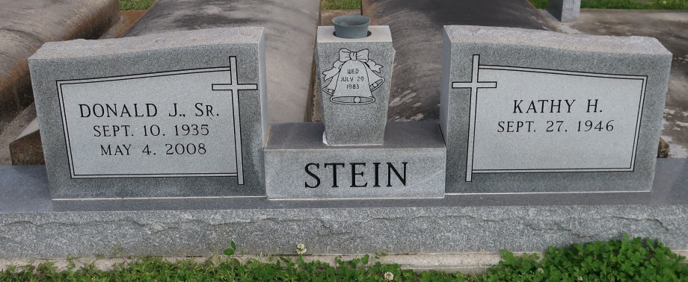

Estate executor for Stein Bros. Plantation and a supervisor and board member of the New River Soil and Water Conservation Board, he died Sunday, May 4, 2008, at his home. He was a lifelong resident of Convent.
Visitation at St. Michael the Archangel Catholic Church, Convent, on Thursday, May 8, from 9 a.m. to 11:50 a.m. Mass of Christian Burial at the church on Thursday at noon, with the Rev. Frank Uter, celebrant. Interment in St. Mary's Chapel Cemetery.
He is survived by his wife, Kathy Heath Stein; and children, Rhonda Barrilleaux and husband Chris, Donna Gail Bratcher and husband Rick, Tanya Mary Boudreaux and husband David, Donald J. Stein Jr. and wife Debbie, and their mother, Nancy Stein. Also survived by a stepson, Keith Adcock; grandchildren, Ian, Simone and Nicole Barrilleaux, Dakota Stein, Kaila, Kourtney, Ashley and Patricia "Ricki" Bratcher, and Dillan and Marissa Boudreaux; and brothers, Harry F. Jr., Roland P. and Roy Stein.
Preceded in death by his father, Harry F. Stein Sr.; mother, Leona Falgoust Stein; and daughter, Ella Marie Stein. Arrangements by Ourso Funeral Home, Gonzales.

The Advocate, Baton Rouge, Louisiana
May 6 to May 7, 2008.

